PET SPHERE

By
Esha Arshad
2012-GCUF-12344
Sadia Noor
2012-GCUF-12344
Mehrose Rizwan
2012-GCUF-12344

Project submitted in partial fulfilment of
the requirements for the degree of

BACHOLAR OF SCIENCE
IN
INFORMATION TECHNOLOGY



DEPARTMENT OF INFORMATION TECHNOLOGY
GC UNIVERSITY, FAISALABAD.

September 2025
DECLARATION

The work reported in this thesis was carried out by me under the supervision of Ms. Zonaira Department of Information Technology GC University, Faisalabad, Pakistan.

I hereby declare that the title of thesis PET SPHERE and the contents of thesis are the product of my own research and no part has been copied from any published source (except the references, standard mathematical or genetic models /equations /formulas/protocols etc). We further declare that this work has not been submitted for award of any other degree /diploma. The University may take action if the information provided is found inaccurate at any stage.

Signature of the Student
Esha Arshad
2012-GCUF-01244

Signature of the Student
Sadia Noor
2012-GCUF-01234

Signature of the Student
Mehrose Rizwan
2012-GCUF-01234

CERTIFICATE BY SUPERVISORY COMMITTEE

We certify that the contents and form of thesis submitted by Ms. Esha Arshad Registration No: 2012-GCUF-01234 by Ms. Sadia Noor Registration No: 2012-GCUF-01234 and by Ms. Mehrose Rizwan Registration No: 2012-GCUF-01234. Has been Found satisfactory and in accordance with the prescribed format. We recommend it to be processed for the evaluation by the External Examiner for the award of Degree.

Signature of Supervisor ………………….
Name.……………………………..………
Designation with stamp………………….

Member of Supervisory Committee
Signature …………….. ………………….
Name.……………………………..………
Designation with stamp………………….

Member of Supervisory Committee
Signature …………….. ………………….
Name.……………………………..………
Designation with stamp………………….
Chairperson

Signature …………….. ………………….
Name.……………………………..………
Designation with stamp………………….

DEDICATED

TO
My Graceful and Polite PARENTS

&
All Family Members
Who live in my mind and soul
Whose love is more precious
Than pearls and diamonds
Who are those whom I say my own
Whose love will never change
Whose prayers will never die

ACKNOWLEDGEMENTS

All praise to ALMIGHTY ALLAH, the most merciful and the most compassionate and his Holy Prophet ‘MUHAMMAD’(Peace) be upon him) the most perfect and exalted among and even born on the surface of earth, who is, forever a torch of guidance and knowledge for the humanity as a whole.
The work presented in this manuscript was accomplished under the inspiring guidance, gorgeous assistance, constructive criticism and enlightened supervision of Ms. Zonaira Department of Information Technology GC University, Faisalabad for his skilful guidance, constructive criticism, masterly advice, valuable suggestions and sympathetic behaviour for the completion of this manuscript.
I feel highly privileged to take this opportunity to express my heartiest gratitude and deep sense of indebt to my worthy supervisory committee, Mr . Mohsin Bilal and Ms. Zonaira Department of Information technology GC University, Faisalabad under whose kind and scholastic guidance, keen interest and constant encouragement.
Words are very important to convey thoughts and thanks, the words are impossible to find to thank our Father and whole family for their prayers and encouragement for us and for our work.
Finally, I apologize if I have caused anger of offence to anybody and the errors that remain in the manuscript are mine alone.

ESHA ARSHAD
SADIA NOOR
MEHROSE RIZWAN

Table of Contents
Contents
1. INTRODUCTION 10
1.1 Background 10
1.2 Overview 11
1.3 Scope and Objectives 11
1.3.1 Scopes 11
1.3.2 Objectives 12
1.4 Assignment of Roles and Responsibilities: 13

INTRODUCTION

Background
“PET SPHERE” a digital platforms that allows customers to conveniently buy pets , book online veterinary appointments, and purchase pet medicines. Currently, many pet-related businesses operate manually or through scattered online services, which can be time-consuming, confusing, and inconvenient for customers. There is no unified system that provides all pet-related services in one place.
The existing process requires customers to visit multiple platforms or physical stores to search for pets, find veterinary doctors, or buy medicines. This causes delays, increases the chance of misinformation, and reduces customer satisfaction. Therefore, there is a clear need for an automated, user-friendly, and reliable platform that simplifies all these services in one system.
To address these challenges, we propose the development of “Pet Sphere”, a web-based application designed to meet customer needs for pet purchasing, veterinary consultation, and medical supplies. The application allows users to search for pets by breed, colour, and other characteristics. Customers can view details, select their desired pet, and complete purchases online. Additionally, the system includes a Doctor Section, where users can book online appointments with veterinary professionals, and a Medical Store Section, where users can purchase pet medicines conveniently.
The admin will manage pet listings, doctor profiles, appointments, and medical inventory. Customers will have access to search, view, and purchase options, as well as manage appointments and orders through their accounts.
Key features of the project “Pet Sphere” is a web-based platform designed to make pet ownership easier and more convenient by offering services like pet purchasing, veterinary appointments, physical Check Up, and medicine orders—all in one place. It includes features such as user registration, login, and profile management, along with a pet marketplace where users can search and buy animals based on breed, colour, and other preferences. The system also provides verified doctor profiles with online consultation options, live availability, and digital prescriptions. A “Pet Passport” feature keeps track of vaccination and medical history, while the emergency system offers an SOS button for quick help and a built-in first-aid guide. Admins can manage users, doctors, medicines, and appointments through a centralized system. The application is developed using React.js, Node.js, Express.js, and MongoDB, with payment integration through Jazz Cash and Easy Paisa, and deployment via Vercel.

Overview
Pet sphere is an all-in-one web application that provides pet lovers with a centralized digital platform where they can purchase their preferred animals, booked veterinary appointments, avail for physical Check Up and order recommended medicines directly from within the app.
The primary goal of this web app is to make the pet ownership experience digital and hassle-free. Users can purchase animals with specific preferences such as name, colour etc. The platform will also feature profiles of qualified veterinary doctors, their live availability status, options for online consultations, and digital medical prescriptions.
An in-app medical store will be available for ordering prescribed medicines. The doctors are also avail for online appointment and physical check Up.

Scope and Objectives
The scope and objective of Pet Sphere are to develop a single online platform that simplifies pet ownership by offering services such as pet purchasing, veterinary appointments, and medicine orders in one place. Its main aim is to digitalize and streamline pet care, ensuring users can easily access pets, doctors, and medical supplies through a convenient and user-friendly web application.

Scopes
The scope of Pet Sphere extends to the creation of a complete and user-friendly online platform that centralizes all essential pet-related services in one system. It focuses on addressing the challenges faced by pet owners who currently have to rely on multiple sources to purchase pets, consult veterinary doctors, or buy pet medicines.
The platform is designed to bring together these scattered services into a single, efficient, and reliable web-based application. Users will be able to browse and purchase pets based on breed, color, and other characteristics, book online appointments with certified veterinary doctors, and order prescribed medicines directly through the integrated medical store.
In addition to serving pet owners, Pet Sphere also supports administrative management by providing a separate admin panel for controlling pet listings, doctor profiles, medical inventory, and appointments. This ensures that all data and operations are well-organized and easily maintained. The system is developed using modern web technologies such as React.js, Node.js, Express.js, and MongoDB, offering seamless performance, real-time updates, and secure online transactions through integrated payment methods like Jazz Cash and Easy Paisa.

Objectives
1. To provide a single online platform for all pet-related services.
2. To make pet purchasing, doctor appointments, and medicine ordering easy and quick.
3. To digitalize and simplify pet care management for users.
4. To connect pet owners with verified veterinary professionals online.
5. To offer a secure and convenient payment system for users.
6. To maintain accurate records of pets, doctors, and medical supplies.
7. To improve customer satisfaction through a user-friendly interface.
8. To save time by reducing the need to visit multiple stores or websites.
9. To ensure smooth management through an efficient admin panel.
10. To promote a reliable and automated pet care experience.

Assignment of Roles and Responsibilities:
Tasks and Member Assignment
Table 1: roles and responsibilities
Sr. | List of Tasks | Roles | Responsibilities
1 | Feasibility Study | Esha Arshad | Conducting and reviewing the study to ensure its completed accurately and supports project decision.
2 | Requirements | Mehrose | Identifying, analysing, and recording the needs of users and the system.
3 | Documentation | Esha Arshad , Sadia Noor, Mehrose | Preparing and maintaining project documents describing processes and system details.
4 | Software Specification | Esha Arshad , Sadia Noor, Mehrose | Writing detailed explanation of functional and technical requirements.
5 | Methodology | Esha Arshad , Sadia Noor, Mehrose | Following an organized approach (Agile Model) to complete project goals efficiently.
6 | Software Designing | Esha Arshad | Designing the application interface and planning how all components will connect and work together.
7 | Software Development | Esha Arshad , Sadia Noor, Mehrose | Writing code, creating algorithms, and developing core features of the application.
8 | Testing | Sadia Noor | Checking the application for errors and ensuring all functions work properly.
9 | Implementation | Mehrose | Launching the software, setting it up, and making sure it runs correctly for users.

Project Schedule
Project Name: “Pet Sphere”
Supervisor Name: Ms. Zonaira
Project Start Date: 20-09-2025

Table 2: Project Schedule
Id | List of Tasks | Dependencies | Duration
A | Feasibility Study | _ | 7 Days
B | Requirements | A | 8 Days
C | Documentation | A, B | 80 Days
D | Software Specification | C | 7 Days
E | Methodology | D | 5 Days
F | Software Designing | D,E | 30 Days
G | Software Development | F | 65 Days
H | Testing | G | 5 Days
I | Implementation | H | 6 Days

Critical path method

Figure 1: Critical path method/network diagram

Table 3: Critical Path Method
Activity | Duration | ES | EF | LS | LF | TS
A | 7 days | 0 | 7 | 0 | 7 | 0
B | 8 days | 7 | 15 | 7 | 15 | 0
C | 80 days | 15 | 95 | 15 | 95 | 0
D | 7 days | 95 | 102 | 95 | 102 | 0
E | 5 days | 102 | 107 | 102 | 107 | 0
F | 30 days | 107 | 137 | 107 | 137 | 0
G | 65 days | 137 | 202 | 137 | 202 | 0
H | 5 days | 202 | 207 | 202 | 207 | 0
I | 6 days | 207 | 213 | 207 | 213 | 0

Giant chart

2. Requirements Specification

2.1- Non-Functional Requirement

Performance

The system should handle up to 500 concurrent users without degradation in response time. Load times must not exceed 3 seconds under normal operating conditions Search queries for pets or services should return results within 2 seconds.
- Scalability
The platform must support horizontal scaling to accommodate future growth in user base and data volume. Database architecture should allow for partitioning and replication to manage increasing pet listings and user interactions.

Security
All user data must be encrypted both in transit (using HTTPS) and at rest. Role-based access control should be enforced for different user types (e.g., adopters, shelter staff, admins).The system must implement protection against common vulnerabilities such as SQL injection, XSS, and CSRF.

Availability
The system should maintain 99.9% uptime, excluding scheduled maintenance. A failover mechanism must be in place to ensure continuity in case of server failure.

Usability
The interface should be intuitive and accessible to users of varying technical proficiency. The platform must comply with WCAG 2.1 accessibility standards to support users with disabilities
- Maintainability

Codebase should follow modular design principles to facilitate updates and bug fixes. Documentation must be maintained for all major components to support future development and onboarding.

Compatibility
The application should be compatible with major browsers (Chrome, Firefox, Safari, Edge) Mobile responsiveness must be ensured across Android and iOS devices.

Reliability
The system should recover gracefully from unexpected errors and log all critical failures. Automated backups must be scheduled daily to prevent data loss.

Localization
The platform should support multiple languages and regional formats to cater to a diverse user base.

Data Integrity
All pet profiles, user data, and transaction records must be stored accurately and consistently. Backup procedures should be automated and verified regularly to prevent data loss.

Product Requirements:

- User Registration and Login
The system must allow pet owners and service providers to create accounts, log in securely, and manage their profiles.
- Pet Information Management
Users should be able to add, update, and view their pets’ details such as name, breed, age, medical history, and vaccination records.
- Appointment Booking System
The system must enable users to book appointments with veterinarians, groomers, and other pet care professionals.
- Online Store Integration
The platform should allow users to browse, select, and purchase pet-related products such as food, accessories, and medicines.
- Pet Health Tracking
The system should maintain health records, vaccination schedules, and reminders for checkups or treatments.
- Emergency Assistance Feature
It must provide quick access to nearby veterinary clinics or emergency services through location tracking.
- Notifications and Alerts
The system should send timely alerts for appointments, vaccinations, and special offers through email or SMS.
- Review and Rating System
Users should be able to review and rate pet services or products to help others make informed choices.
- Admin Dashboard
The admin must have access to manage users, monitor activities, update product listings, and handle system maintenance.
- Responsive Design
The application must be compatible with mobile, tablet, and desktop devices for better accessibility.

Organizational Requirements:
- Project Management Structure:
A clear hierarchy should be established to assign roles, responsibilities, and communication flow within the development team.
- Resource Allocation:
The organization must provide necessary resources such as hardware, software tools, and internet access for efficient project development.
- Team Collaboration:
Developers, designers, and testers should work in coordination using collaborative tools like Slack or Trello for smooth workflow management.
- Quality Standards:
The project must follow organizational coding standards, testing procedures, and documentation practices to ensure reliability and maintainability.
- Security and Data Policies:
The organization should enforce policies for secure handling of user and pet data, including proper authentication and access control.
- Training and Skill Development:
Team members should be trained in new technologies and tools relevant to the Pet Sphere system to improve project quality and efficiency.
- Performance Evaluation:
Regular progress reviews and evaluations should be conducted to ensure the project aligns with organizational goals and deadlines.

External Requirements:
- Legal Requirements:
The system must follow all legal rules related to user data privacy, pet registration, and online business operations.
- Security Requirements:
The platform should protect user and pet information from hackers or unauthorized access.
- User Requirements:
The system must be user-friendly, easy to navigate, and accessible on different devices like mobile and computer.
- Compatibility Requirements
Pet Sphere should work properly on different browsers and operating systems without errors.

- Performance Requirements
The website should load quickly and handle multiple users at the same time without slowing down.
- Regulatory Requirements
The project must follow IT regulations, data protection laws, and online payment standards if payments are included.

Functional Requirements:
- User Registration & Login
Users can create accounts, log in, and manage their profiles securely.
- Pet Profile Management
Users can add, update, or delete information about their pets.
- Pet Services Booking
Users can book services like grooming, vet appointments, or training through the system.
- Notifications & Alerts
Users receive reminders for appointments, vaccinations, and other pet-related events.
- Search & Browse Pets/Services
Users can search for pets, services, or products easily with filters and categories.
- Payment Integration
Users can make secure online payments for services and products.
- Feedback & Reviews
Users can give ratings and feedback on services or products.
- Admin Panel
Admin can manage users, services, bookings, and monitor system performance.

Category 1: General Website / Public Pages
- Home Page
Overview of the platform, featured services, and latest updates.
- About Us
Information about the company, mission, and vision.
- Services Page
List of pet services like grooming, vet visits, training, etc.
- Products Page
Pet-related products available for sale.
- Contact Us
Contact form, phone numbers, email, and location.
- FAQs
Answers to common questions about the platform and services.
- Blog / Tips
Articles about pet care, health, and training.
- Testimonials / Reviews
Feedback from users about services and products.
- Registration / Login Page
For users to create accounts or log in.

Category 2: Client Panel:
- Dashboard
Overview of user account, upcoming appointments, and pet summary.
- My Pets
Add, update, or remove pet profiles with details like age, breed, and health records.
- Book Services
Schedule grooming, vet visits, training, or other pet services.
- My Bookings / Appointments
View upcoming and past service bookings with status updates.
- Payments
Manage online payments, invoices, and payment history securely.
- Notifications / Reminders
Receive alerts for appointments, vaccinations, or special offers.
- Feedback / Reviews
Submit reviews or feedback for completed services.
- Profile Settings
Update personal info, password, and contact details.

Category 3: Employee Panel

Dashboard

Shows daily tasks and appointments for employees.
- Manage Appointments
Allows staff to view, accept, or cancel customer bookings.
- Pet Records
Employees can update and check pet medical or grooming details.
- Customer Interaction
Enables staff to communicate with customers easily.
- Service Tracking
Tracks the progress of all pet-related services.
- Profile Management
Let employees update their personal and work details.

Category 4: Admin Panel
- User Management: Handles registration, updates, and removal of users.
- Pet Management: Manages pet profiles, adoption details, and approvals.
- Product Management: Adds, edits, or removes pet products and accessories.
- Order Management: Tracks and manages user orders and service bookings.
- Feedback & Support: Reviews user feedback and resolves complaints.
- Reports & Analytics: Generates system and sales reports for performance review.
- Content Management: Updates website information, offers, and announcements.

3_ANALYSIS
3.1. Domain Model
A domain model is a visual representation of the main concepts, entities, and their relationships within a specific domain of a system. It helps in understanding the real-world objects that the system will manage and how they interact with each other.

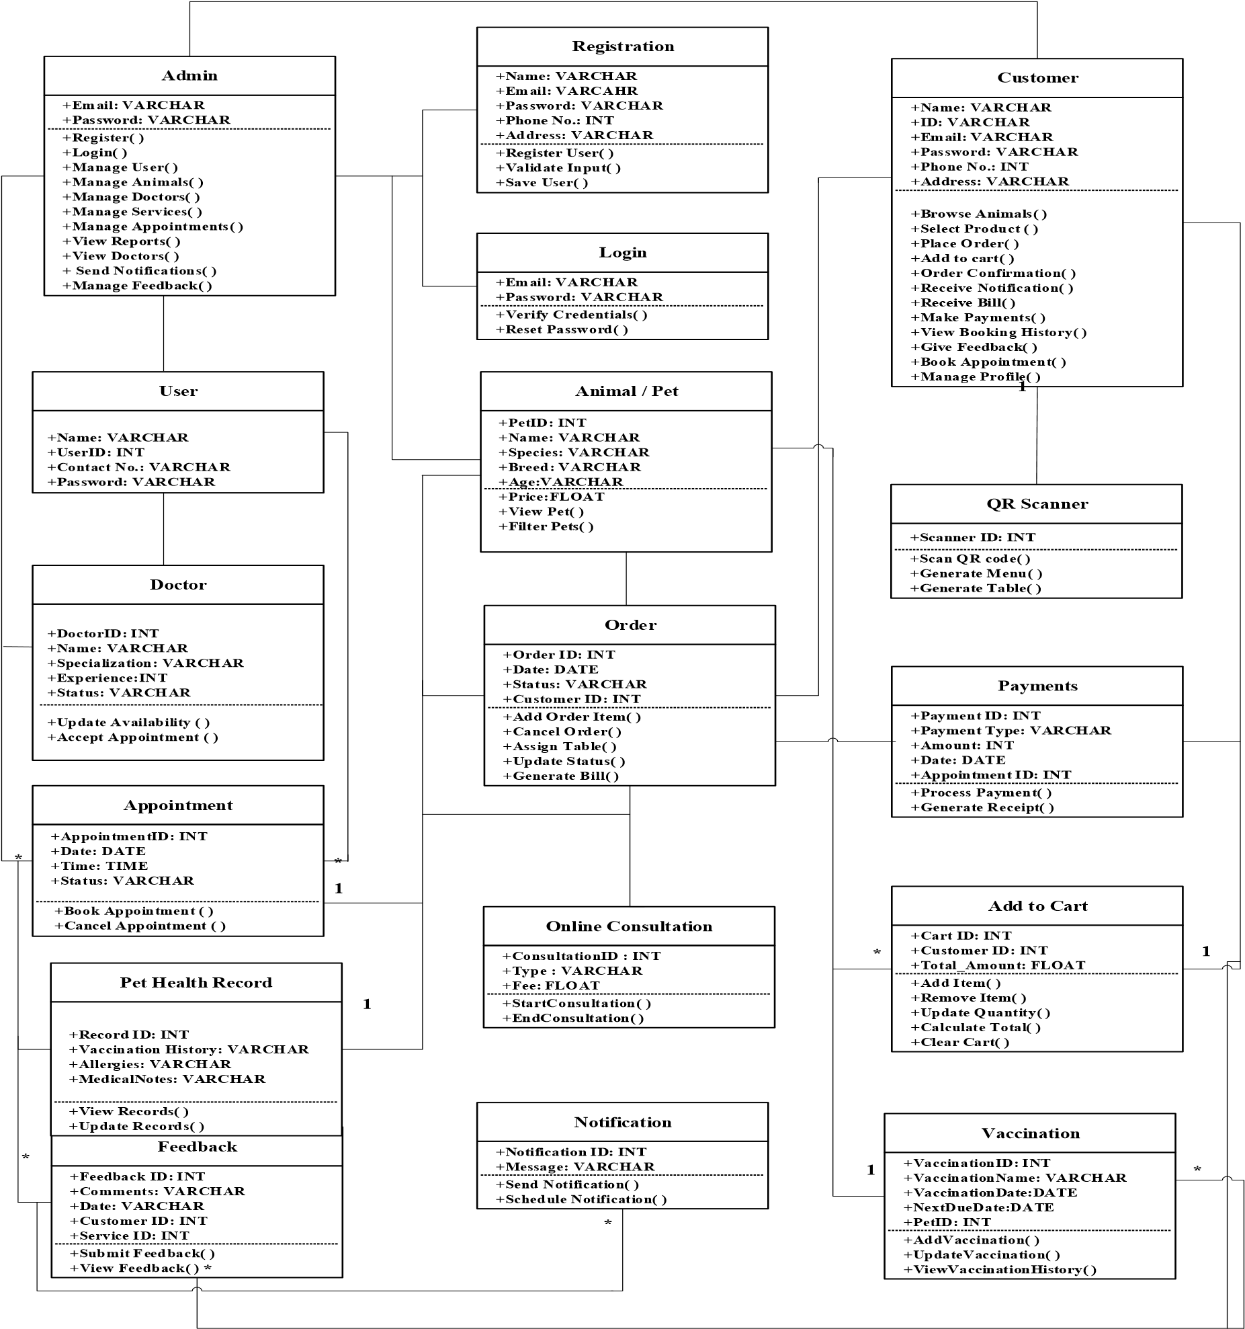

3.2. Stakeholders
Stakeholders are the individuals, groups, or organizations that are directly or indirectly involved in a project or are affected by its outcomes. They play an important role in providing requirements, feedback, supervision, and resources for the successful completion of the project. Stakeholders may include developers, clients, end-users, and supervisors.
Stakeholders
First stakeholder is Esha Arshad , working as a developer in the Information Technology Department at Standard Girls College, Sialkot on a project for Pet Sphere . This project is customized according to the pet sphere system requirements.
Second stakeholder is Sadia Noor , working as a developer in the Information Technology
Department at Standard Girls College, Sialkot on a project for Pet Sphere . This project is customized according to the pet sphere system requirements.

Third stakeholder is Mehrose Ajmal , working as a developer in the Information Technology
Department at Standard Girls College, Sialkot on a project for Pet Sphere . This project is customized according to the pet sphere system requirements. Supervisor
Under the supervision of Ma’am Zonaira, from the IT & CS Department . we are designing and developing the system for Pet Sphere Project. She provided guidance, monitoring, and academic support throughout the development process to ensure the project meets technical and educational standards.

3.3. High-Level Use Case Model
A use case model is a visual representation that shows the interaction between users also called actors and the system. It helps to identify what the users can do with the system and what the system should provide in return. Each interaction is shown as “use case” which represents a specific function or service. This model is useful for understanding system requirements and designing how the system will work from a user’s point of view. It is often represented using UML diagrams.

3.4. Low Level Use Case Models

3.4.1. Use Case Admin Registration
This is the entry point of Pet Sphere System. Only authorize user can register to the system with authenticated user name, email, address, phone number and password.
Admin
Registration
User Name
Email
Password
Phone No.
Address

Use Case ID: Use Case 01_Registration Use Case
Name: Admin Registration
Actor | Admin | Web Based Application
Purpose | Manage user accounts (add, update, delete, view) | Provide user management functionality
Pre-condition | Admin must be logged in | System must be running properly
Course of Events | 1-Admin selects Manage Users. | 1- Displays user lists
 | 2- Add / update / delete user | 2- Validate data
 |  | 3- Saves changes
Alternative Course of events | Admin enters invalid data | System shows error message
Post condition | Users are managed successfully | User records are updated

3.4.2. Use Case Admin Login
Only authorize user can login to the system with authenticated user name and passw

Table 14: Admin Management
Use Case ID: Use Case 02_Login Use Case
Name: Admin Login
Actor | Admin | Web Based Application
Purpose | Admin login to perform actions.
Pre-condition | Web-application running perfectly.
Course of Events | 1-Admin will enter the email and password. | 1-Web-application checks that the admin enter the correct email and password.
 | 2-Application checks the email and password is valid or not, if entered information is correct then the admin will be able to access the website. | 2-If admin enters incorrect information, the application will show the error message, that the admin cannot have access to website.
 | 3-Admin will login to view/perform any actions. | 3- Admin will have to re-enter the information again.
Alternative Course of events | Web-application will not Respond.
Post condition | Web-application runs successfully. | The requested service is not available.

3.4.3. Use Case Admin Panel

The admin can interact with all other modules in the system after logging in. This will provide all the functions in a single view point.

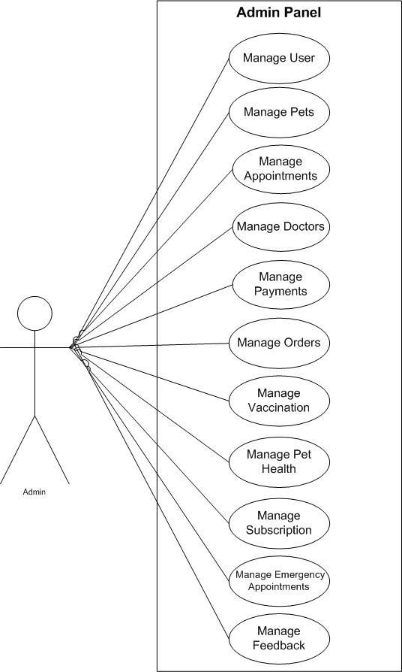

.4.4. Use Case Admin Manage User
The admin can add new salon services, update existing ones, or remove outdated services to keep the services list current and accurate
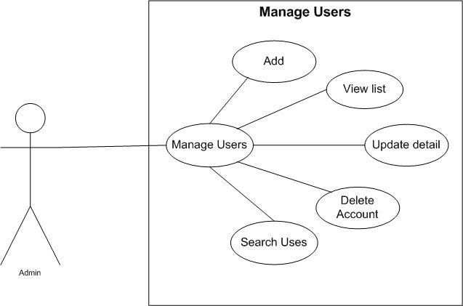
Figure 15: Manage User
Table 14: Manage User
Use Case ID: Use Case 03_Manage_Services Use Case
Name: Manage_Services
Actor | Admin | Web Based Application
Purpose | Admin can add, delete, or update services.
Pre-condition | Web-application running perfectly. | System connected to database.
Course of Events | 1-Admin opens “Manage Services” page and selects add/update/delete option. | 1-Web-application validates entered data.
 | 2-Enters or edits details like Service ID, Name, Category, and Duration. | 2-Performs database update.
 | 3.Save changes. | 3-Confirms success message.
Alternative Course of events | If Service information is invalid or connection fails. | Web app shows “Unable to process request.”
Post condition | Service list updated successfully. | Database reflects new/updated/deleted records.
3.4.5. Use Case Admin Manage Pets
The admin oversees all customer bookings, ensuring appointments are properly scheduled, approved, or rescheduled when necessary.
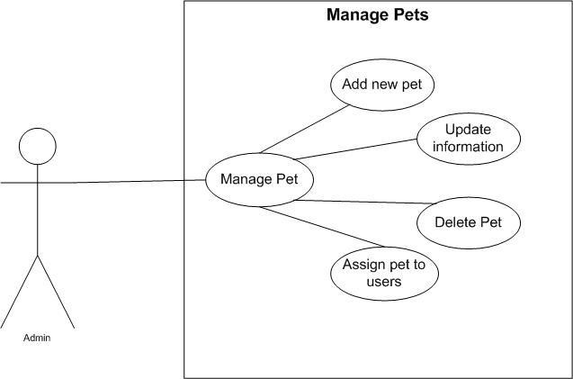
Figure 15: Manage Pet
Table 14: Manage Pet
Use Case ID: Use Case 04_Manage_Pets Use Case Name:
Manage Pets
Actor | Admin | Web Based Application
Purpose | Manage all pets data | Maintain pet records
Pre-condition | Admins logged in | Database available
Course of Events | 1-Admin selects Manage pets | 1-Displays pet list
 | 2- Views / Updates pet data | 2- Saves updates
Alternative Course of events | Pet record not found | System shows error
Post condition | Pet data updated | Pet records stored

3.4.6. Use Case Admin Manage Appointments
This module allows the admin to add, update, or remove employee details and assign roles to ensure smooth operations.
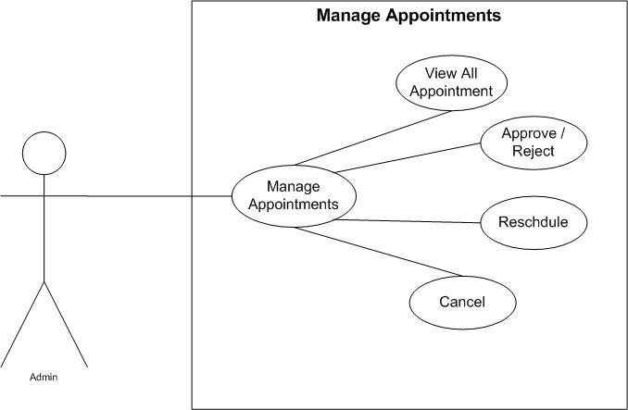
Figure 15: Manage Appointments
Table 14: Manage Appointments
Use Case ID: Use Case 05_Manage_Appointments Use
Case Name: Manage Appointments
 | Actor |  | Admin |  | Web Based Application
 | Purpose |  | View and manage appointments |  | Handle appointment scheduling
 | Pre-condition |  | Admin logged in |  | System active
 | Course of Events |  | 1-Admin selects manage appointments |  | 1-Display appointments
 |  |  | 2-Approve / Cancels appointments |  | 2-Updates status.
 | Alternative Course of events |  | Appointment not available |  | Error message displayed
 | Post condition |  | Appointment managed |  | Appointment status updated

3.4.7. Use Case Admin Manage Doctor
The admin can view and track all past customer appointments for performance monitoring and reporting purposes.
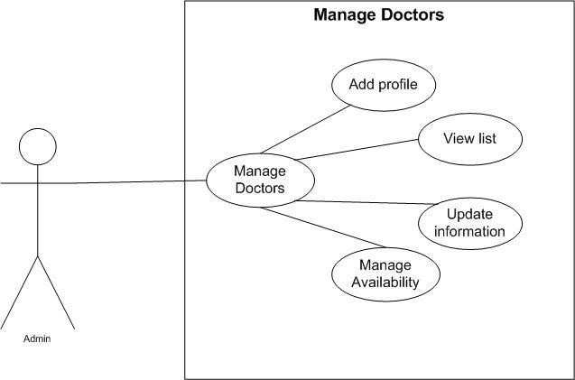
Figure 15: Manage Doctor
Table 14: Manage Doctor
Use Case ID: Use Case 06_Manage_Doctor Use Case Name:
Manage Doctor
Actor | Admin | Web Based Application
Purpose | Add, update, remove doctors | Store doctor information
Pre-condition | Admin logged in | System available
Course of Events | 1-Admin selects Manage Doctors | 1-Validates data
 | 2- Enters doctor details | 2- Saves doctor record
Alternative Course of events | Duplicate doctor record | Error message shown
Post condition | Doctor data updated | Doctor list updated

3.4.8. Use Case Admin Payment
This module helps the admin view, generate, and analyze payment transactions and financial summaries making.
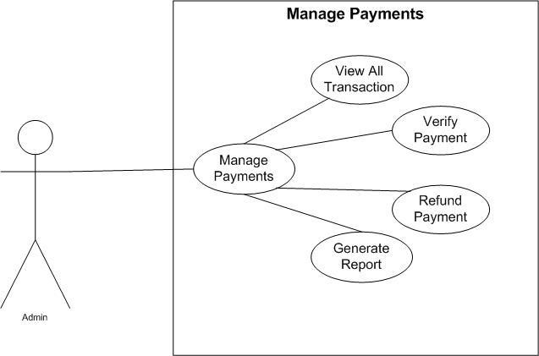
Figure 15: Manage Payments
Table 14: Manage Payments
Use Case ID: Use Case 06_Manage_Payments Use Case Name:
Manage Payments
Actor | Admin | Web Based Application
Purpose | Monitor and manage payments | Process payment records
Pre-condition | Admin logged in | Payment system active
Course of Events | 1-Admin views payments | 1-Displays payment data
 | 2-Confirms transaction | 2-Updates payment status
Alternative Course of events | Payment data missing | Error shows
Post condition | Payment verified | Payment records updated

3.4.8. Use Case Admin Manage Orders
This module helps the admin view, generate, and analyze payment transactions and financial summaries making.
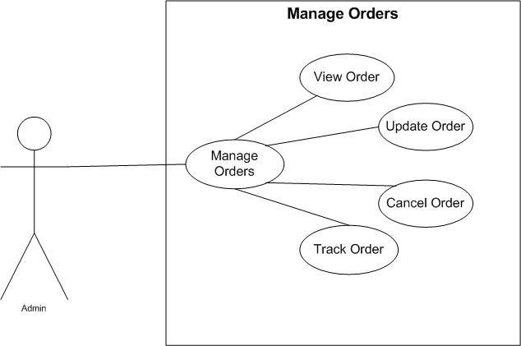
Figure 15: Manage Orders
Table 14: Manage Orders
Use Case ID: Use Case 06_Manage_Orders Use Case Name:
Manage Orders
Actor | Admin | Web Based Application
Purpose | Manage customer orders | Handle order processing
Pre-condition | Admin logged in | Inventory available
Course of Events | 1-Admin views orders | 1-Displays order list
 | 2-Updates order status | 2-Saves status
Alternative Course of events | Order not found | Error message
Post condition | Order managed | Order updated

3.4.8. Use Case Admin Manage Vaccination
This module helps the admin view, generate, and analyze payment transactions and financial summaries making.
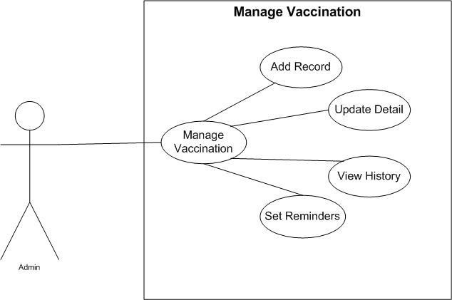
Figure 15: Manage Vaccination
Table 14: Manage Vaccination
Use Case ID: Use Case 06_Manage_Vaccination Use Case Name:
Manage Vaccination
Actor | Admin | Web Based Application
Purpose | Maintain vaccination records | Store vaccination data
Pre-condition | Admin logged n | Pet record exists
Course of Events | 1- Admin updates vaccination info | 1-. Validates data
 |  | 2-Saves record
Alternative Course of events | Invalid vaccination data | Error shown
Post condition | Vaccination updated | Vaccination record saved
3.4.8. Use Case Admin Manage Pet Health
This module helps the admin view, generate, and analyze payment transactions and financial summaries making.

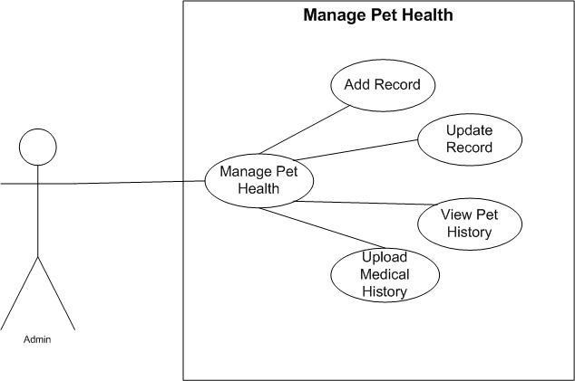
Figure 15: Manage Pet Health
Table 14: Manage Pet Health
Use Case ID: Use Case 06_Manage_Pet_Health Use Case Name:
Manage Pet Health
Actor | Admin | Web Based Application
Purpose | Monitor pet health records | Maintain health history
Pre-condition | Admin logged in | Pet data available
Course of Events | 1- Admin views / updates health data | 1- Displays health information
 |  | 2-Save changes
Alternative Course of events | Health data missing | Error shown
Post condition | Health data updated | Health record stored

3.4.8. Use Case Admin Manage Subscription
This module helps the admin view, generate, and analyze payment transactions and financial summaries making.
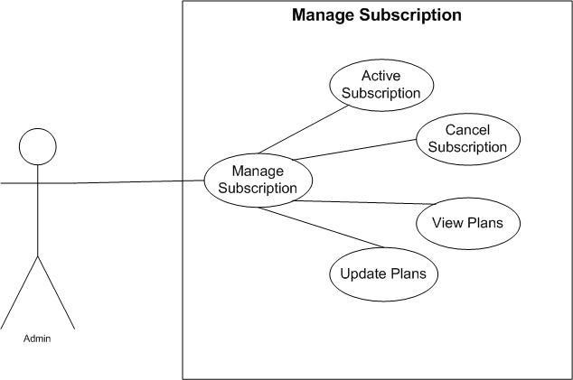
Figure 15: Manage Subscription
Table 14: Manage Subscription
Use Case ID: Use Case 06_Manage_Subscription Use Case
Name: Manage Subscription
Actor | Admin | Web Based Application
Purpose | Manage user subscription | Handle subscription plans
Pre-condition | Admin logged in | Subscription module active
Course of Events | 1- Admin updates subscription plans | 1- Displays plans
 |  | 2- Saves updates
Alternative Course of events | Subscription error | Error displayed
Post condition | Subscription managed | Subscription updated

.8. Use Case Admin Manage Emergency Alert
This module helps the admin view, generate, and analyze payment transactions and financial summaries making.
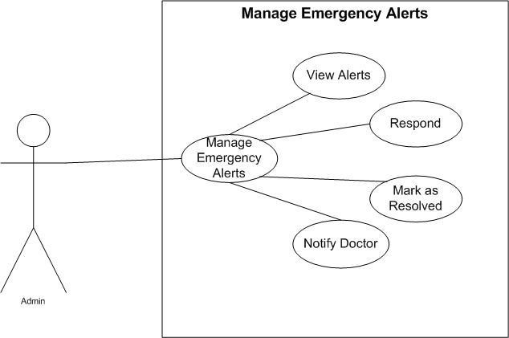
Figure 15: Manage Emergency Alerts
Table 14: Manage Emergency Alerts
Use Case ID: Use Case 06_Manage_Emergency_Alerts Use Case
Name: Manage Emergency Alerts
Actor | Admin | Web Based Application
Purpose | Handle emergency requests | Notify doctors and users
Pre-condition | Admin logged in | Emergency system active
Course of Events | 1- Admin views emergency alerts | 1- Sends notifications
 |  | 2-Updates alert status
Alternative Course of events | No doctor available | Alert remains pending
Post condition | Emergency handled | Alert processed
3.4.8. Use Case Admin Manage Feedback
This module helps the admin view, generate, and analyze payment transactions and financial summaries making.
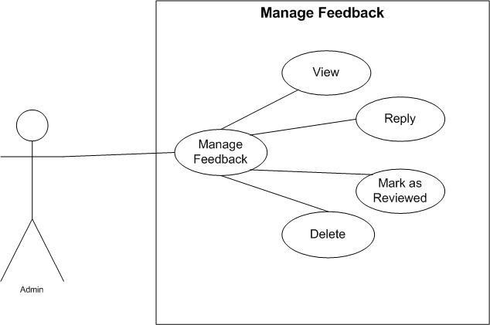
Figure 15: Manage Feedback
Table 14: Manage Feedback
Use Case ID: Use Case 06_Manage_Feedback Use Case Name:
Manage Feedback
Actor | Admin | Web Based Application
Purpose | View and manage feedback | Store feedback data
Pre-condition | Admin logged in | Feedback module active
Course of Events | 1- Admin views feedback | 1-Display Feedback list
Alternative Course of events | Feedback not available | Message Shown
Post condition | Feedback reviewed | Feedback stored successfully

1.1.1. Use Case Customer Registration & Login

Figure 19: Customer Registration & Login

Table 18: Customer Registration & Login

Use Case ID: Use Case 01_Customer_Registration_and_Login Use Case Name: Customer_Registration and_Login
Actor | Customer | Web Based Application
Purpose | Customer can register to perform actions.
Pre-condition | Web-application running perfectly.
Course of Events | 1-Customer will Request for registration. The System will load the register form and Display. Customer will provide the register form information. | 1-Web-application checks that the customer enters the correct username, email, and password.
 | 2-The System will verify and if customer provide correct information. | 2-If customer enters incorrect information, he/she will not have access to the website.
 |  | 3-Customer will have to re- enter the information again.
Alternative Course of events | Web-application will not Respond.
Post condition | Web-application runs successfully. | The requested service is not available.

Customer Panel
The customer can interact with all other modules in the system after logging in. This will provide all the function information in a single view point.

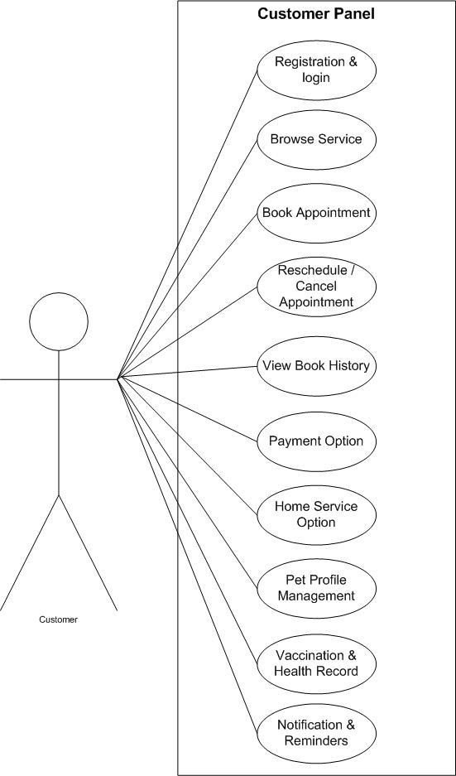

3.4.8. Use Case Admin Manage Feedback
This module helps the admin view, generate, and analyze payment transactions and financial summaries making.
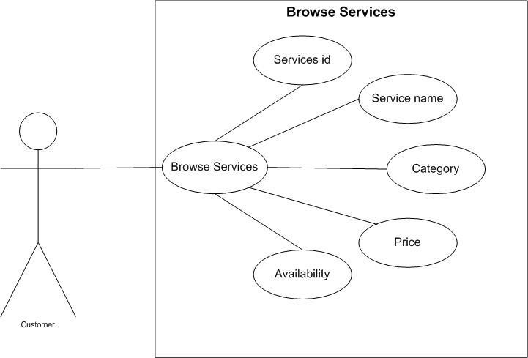

Figure 21: Browse List of Services
Table 19: Browse List of Services

Use Case ID: Use Case 02_Browse_List_of_Services Use Case Name: Browse List of Services
Actor | Customer | Web Based Application
Purpose | View available pet services | Display services
Pre-condition | Customer logged in | Services available
Course of Events | 1-Customer selects browse services | 1-Display service list
Alternative Course of events | No service available | Shows message
Post condition | Services viewed | Service shown

3.4.8. Use Case Admin Manage Feedback
This module helps the admin view, generate, and analyze payment transactions and financial summaries making.
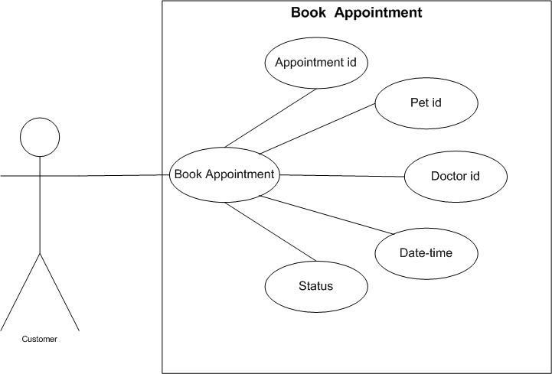
Figure 21: Book Appointment
Table 19: Book Appointment

Use Case ID: Use Case 02_Browse_Appointment Use Case Name: Book Appointment
Actor | Customer | Web Based Application
Purpose | Book appointment with doctor | Schedule appointment
Pre-condition | Customer logged in, pet registered | Appointment slots available
Course of Events | 1-Selets doctor / date / time | 1-Confirms appointment
Alternative Course of events | Slot unavailable | Shows error
Post condition | Appointment booked | Appointment stored

3.4.8. Use Case Admin Manage Feedback
This module helps the admin view, generate, and analyze payment transactions and financial summaries making.
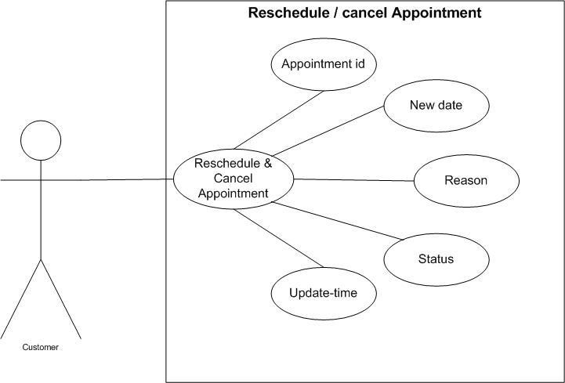
Figure 21: Reschedule / Cancel Appointment
Table 19: Reschedule / Cancel Appointment

Use Case ID: Use Case
02_Reschedule_Appointment
Use Case Name: Reschedule/Cancel Appointment
Actor | Customer | Web Based Application
Purpose | Modify or cancel appointment | Updated appointment
Pre-condition | Existing appointment | System active
Course of Events | 1- Selects appointments, Reschedule  / cancel | 1-Updated appointment
Alternative Course of events | Appointment not found | Shows error
Post condition | Appointment updated | Record updated
3.4.8. Use Case Admin Manage Feedback
This module helps the admin view, generate, and analyze payment transactions and financial summaries making.
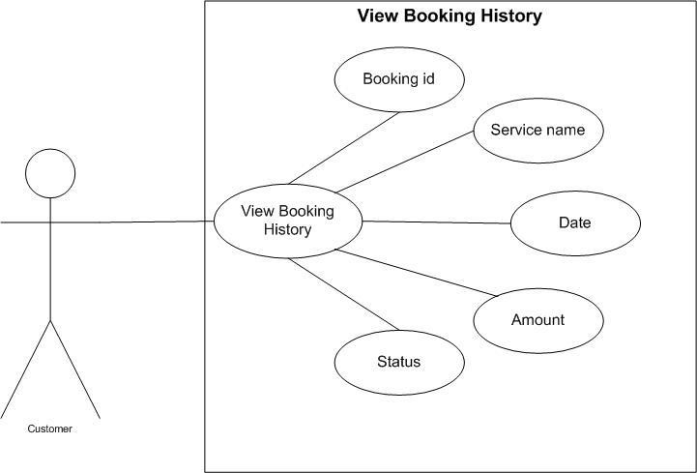
Figure 21: View Booking History
Table 19: View Booking History

Use Case ID: Use Case 02_View_Booking_History Use Case Name: View Booking History
Actor | Customer | Web Based Application
Purpose | View past appointments | Display history
Pre-condition | Customer logged in | Booking data available
Course of Events | 1-Selects booking history | 1-Display history
Alternative Course of events | No history | Shows message
Post condition | History viewed | History shown

3.4.8. Use Case Admin Manage Feedback
This module helps the admin view, generate, and analyze payment transactions and financial summaries making.
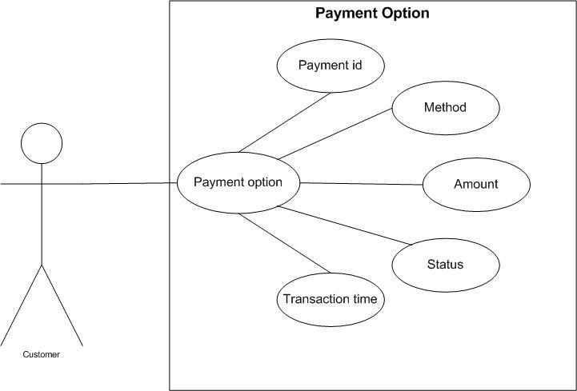
Figure 21: Payment Option
Table 19: Payment Option

Use Case ID: Use Case 02_Browse_List_of_Services Use Case Name: Payment Option
Actor | Customer | Web Based Application
Purpose | Make payment for services | Process payment
Pre-condition | Appointment/ order exists | Payment gateway active
Course of Events | 1-Selects payment method | 1-Processes payment
Alternative Course of events | Payment failed | Shows failure message
Post condition | Payment completed | Payment recorded
3.4.8. Use Case Admin Manage Feedback
This module helps the admin view, generate, and analyze payment transactions and financial summaries making.
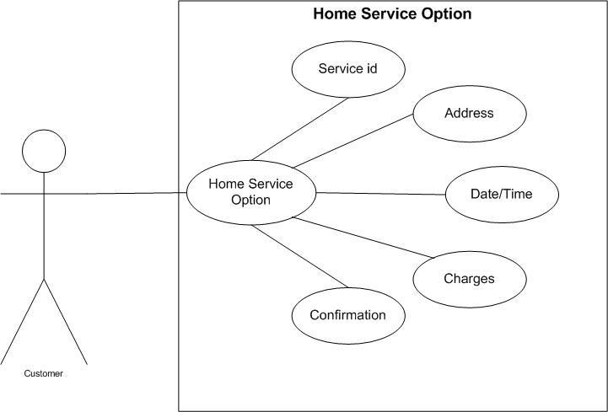
Figure 21: Home Service Option
Table 19: Home Service Option
Use Case ID: Use Case 02_Browse_List_of_Services Use Case Name: Home Service Option
Actor | Customer | Web Based Application
Purpose | Request home service | Schedule home visit
Pre-condition | Customer logged in | Service available
Course of Events | - Selects home Service | 1-Confirms request
Alternative Course of events | Service unavailable | Shows message
Post condition | Home service requested | Request saved

3.4.8. Use Case Admin Manage Feedback
This module helps the admin view, generate, and analyze payment transactions and financial summaries making.
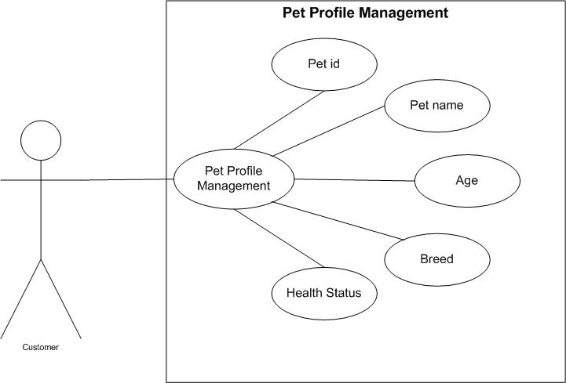
Figure 21: Pet Profile Management
Table 19: Pet Profile Management

Use Case ID: Use Case 02_Browse_List_of_Services Use Case Name: Pet Profile Management
Actor | Customer | Web Based Application
Purpose | Manage pet profile | Store pet data
Pre-condition | Customer logged in | Database available
Course of Events | 1-Adds / Updates pet info | 1-Saves pet profile
Alternative Course of events | Invalid data | Shows error
Post condition | Pet profile updated | Data saved

Use Case Customer Vaccination and Health Record
Customers can view all available salon/spa services along with their name, category, duration, and price.

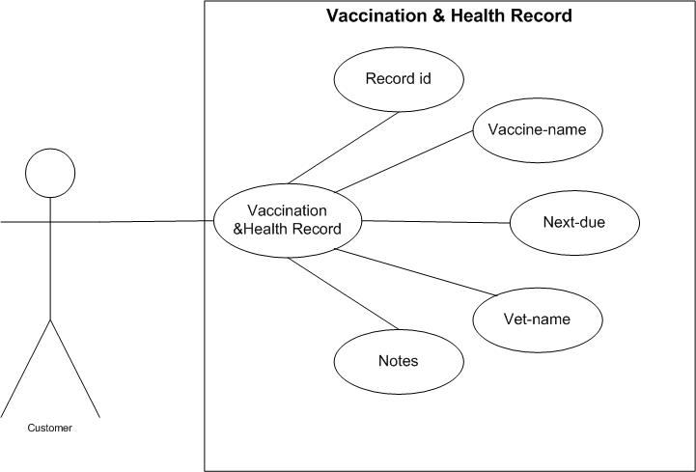

Figure 21: Vaccination & Health Record
Table 19: Vaccination & Health Record

Use Case ID: Use Case 02_Browse_List_of_Services Use Case Name: Vaccination & Health Record
Actor | Customer | Web Based Application
Purpose | View pet health records | Display records
Pre-condition | Pet registered | Records available
Course of Events | 1-Views vaccination & health | 1-Shows records
Alternative Course of events | Records not found | Shows message
Post condition | Records viewed | Records displayed

Use Case Customer Notification and Reminders
Customers can view all available salon/spa services along with their name, category, duration, and price.

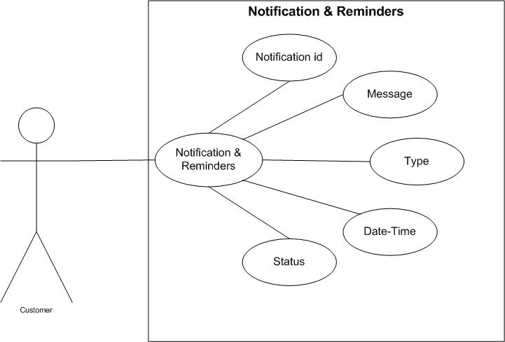

Figure 21: Notification & Reminders
Table 19: Notification & Reminders

Use Case ID: Use Case 02_Notification_and_Reminders
Use Case Name: Notification & Reminders
Actor | Customer | Web Based Application
Purpose | Receive notification | Send reminders
Pre-condition | Customer logged in | Notification service active
Course of Events | 1-Recieves notification | 1-Sends alerts
Alternative Course of events | Notification failure | Retry sending
Post condition | Notification received | Notification logged

Use Case Doctor Registration & Login

User Name
<<include>>
Accept
Login
Failed
<<include>>
Reject
Customer
Password
Figure 19: Customer Registration & Login
Table 18: Customer Registration & Login

Use Case ID: Use Case 01_Customer_Registration_and_Login Use Case Name: Customer Registration and Login
Actor | Customer | Web Based Application
Purpose | Login or register into the system | Authentication doctor
Pre-condition | Doctor has valid credentials | System running properly
Course of Events | 1-Doctor enters logical registration details | 1-Validates information
 |  | 2-Grants access
Alternative Course of events | Invalid credentials | Error message displayed
Post condition | Doctor logged in | Session created

Use Case Doctor Panel
The customer can interact with all other modules in the system after logging in. This will provide all the function information in a single view point.

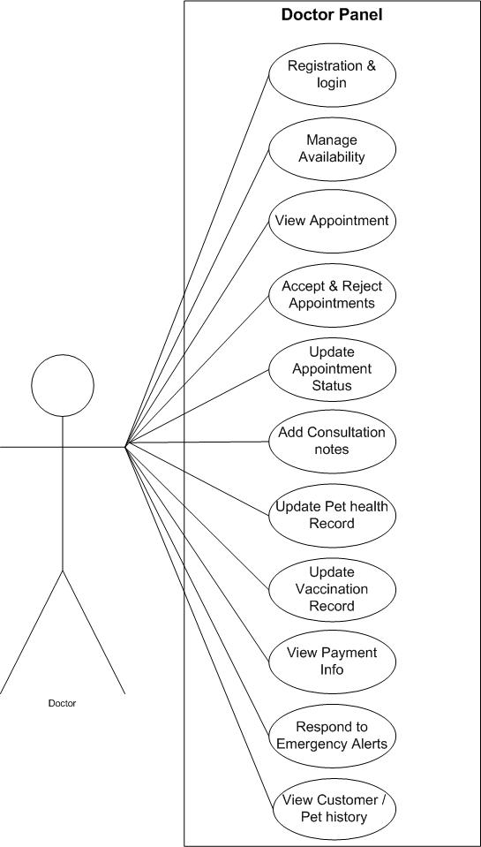

Use Case Customer Manage Availability
Customers can view all available salon/spa services along with their name, category, duration, and price.

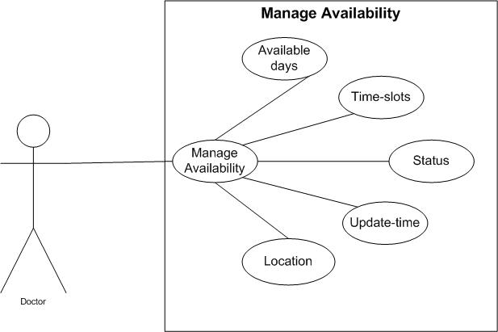

Figure 21: Manage Availability
Table 19: Manage Availability

Use Case ID: Use Case 02_Manage_Availability
Use Case Name: Manage Availability
Actor | Doctor | Web Based Application
Purpose | Set available time slots | Store availability
Pre-condition | Doctor sets availability | Calendar available
Course of Events | 1-Doctor sets availability | 1-Saves schedule
Alternative Course of events | Invalid time slot | Error shown
Post condition | Availability updated | Schedule saved

Use Case Customer View Appointments
Customers can view all available salon/spa services along with their name, category, duration, and price.

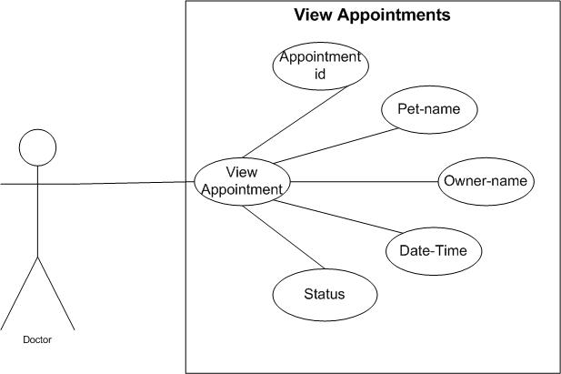

Figure 21: View Appointments
Table 19: View Appointments

Use Case ID: Use Case 02_View_Appointments
Use Case Name: View Appointments
Actor | Doctor | Web Based Application
Purpose | View based appointments | Display appointments
Pre-condition | Doctor logged in | Appointments exist
Course of Events | 1-Doctor views appointments | 1-Shows appointment list
 | 2- | 2-
Alternative Course of events | No appointments | Shows message
Post condition | Appointments viewed | Appointments displayed

Use Case Customer Accept / Reject
Customers can view all available salon/spa services along with their name, category, duration, and price.

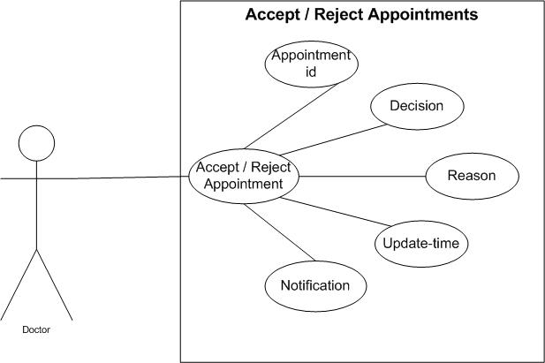

Figure 21: Browse List of Services
Table 19: Browse List of Services

Use Case ID: Use Case 02_Browse_List_of_Services Use Case Name: Browse_List_of_Services
Actor | Customer | Web Based Application
Purpose
Pre-condition
Course of Events | 1- | 1-
 | 2- | 2-
Alternative Course of events
Post condition

Use Case Customer Accept / Reject
Customers can view all available salon/spa services along with their name, category, duration, and price.

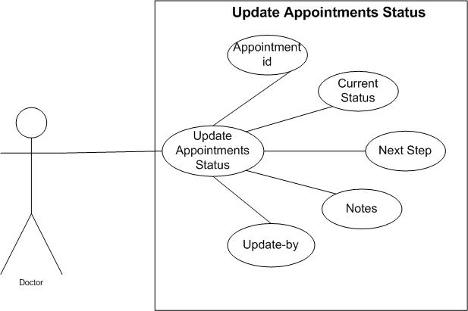

Figure 21: Browse List of Services
Table 19: Browse List of Services

Use Case ID: Use Case 02_Browse_List_of_Services Use Case Name: Browse_List_of_Services
Actor | Customer | Web Based Application
Purpose
Pre-condition
Course of Events | 1- | 1-
 | 2- | 2-
Alternative Course of events
Post condition | .

Use Case Customer Accept / Reject
Customers can view all available salon/spa services along with their name, category, duration, and price.

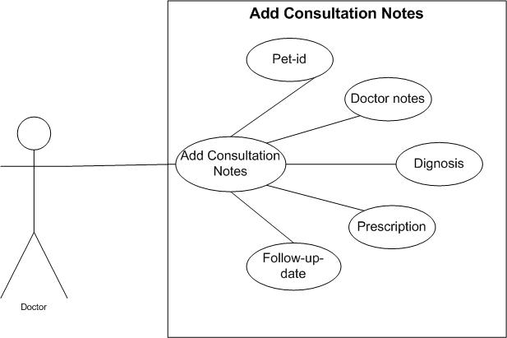

Figure 21: Browse List of Services
Table 19: Browse List of Services

Use Case ID: Use Case 02_Browse_List_of_Services Use Case Name: Browse_List_of_Services
Actor | Customer | Web Based Application
Purpose
Pre-condition
Course of Events | 1- | 1-
 | 2- | 2-
Alternative Course of events
Post condition

Use Case Customer Accept / Reject
Customers can view all available salon/spa services along with their name, category, duration, and price.

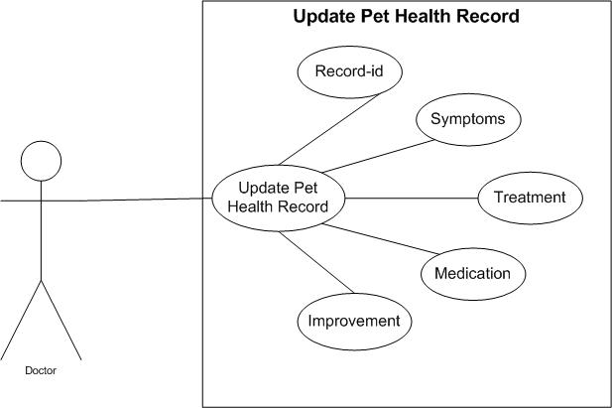
Figure 21: Browse List of Services
Table 19: Browse List of Services

Use Case ID: Use Case 02_Browse_List_of_Services Use Case Name: Browse_List_of_Services
Actor | Customer | Web Based Application
Purpose
Pre-condition
Course of Events | 1- | 1-
 | 2- | 2-
Alternative Course of events
Post condition

Use Case Customer Accept / Reject
Customers can view all available salon/spa services along with their name, category, duration, and price.

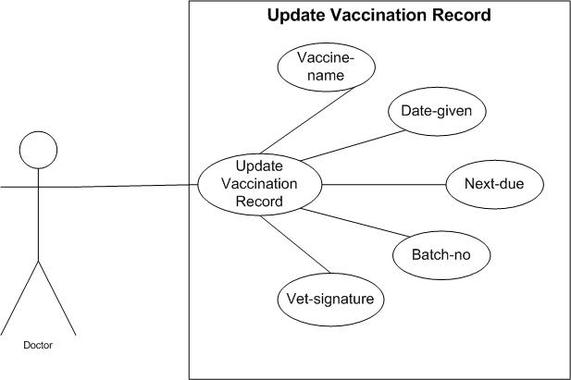
Figure 21: Browse List of Services
Table 19: Browse List of Services

Use Case ID: Use Case 02_Browse_List_of_Services Use Case Name: Browse_List_of_Services
Actor | Customer | Web Based Application
Purpose
Pre-condition | .
Course of Events | 1- | 1-
 | 2- | 2-
Alternative Course of events
Post condition

Use Case Customer Browse List of Services
Customers can view all available salon/spa services along with their name, category, duration, and price.

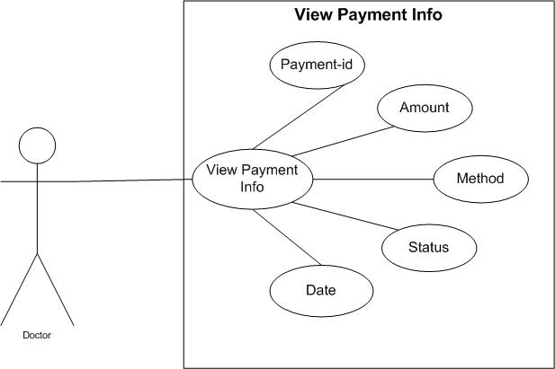

Figure 21: Browse List of Services
Table 19: Browse List of Services

Use Case ID: Use Case 02_Browse_List_of_Services Use Case Name: Browse_List_of_Services
Actor | Customer | Web Based Application
Purpose
Pre-condition | .
Course of Events | 1- | 1-
 | 2- | 2-
Alternative Course of events
Post condition

Use Case Customer Browse List of Services
Customers can view all available salon/spa services along with their name, category, duration, and price.

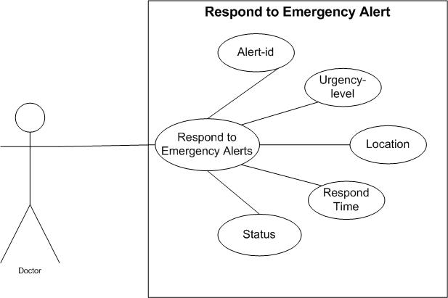

Figure 21: Browse List of Services
Table 19: Browse List of Services

Use Case ID: Use Case 02_Browse_List_of_Services Use Case Name: Browse_List_of_Services
Actor | Customer | Web Based Application
Purpose
Pre-condition
Course of Events | 1- | 1-
 | 2- | 2-
Alternative Course of events
Post condition

Use Case Customer Browse List of Services
Customers can view all available salon/spa services along with their name, category, duration, and price.

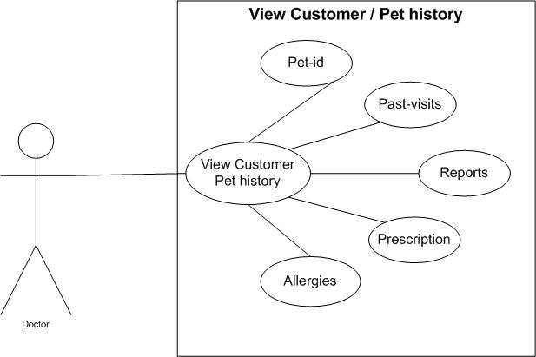

Figure 21: Browse List of Services
Table 19: Browse List of Services

Use Case ID: Use Case 02_Browse_List_of_Services Use Case Name: Browse_List_of_Services
Actor | Customer | Web Based Application
Purpose
Pre-condition
Course of Events | 1- | 1-
 | 2- | 2-
Alternative Course of events
Post condition

Use Case Customer Browse List of Services
Customers can view all available salon/spa services along with their name, category, duration, and price.



Figure 21: Browse List of Services
Table 19: Browse List of Services

Use Case ID: Use Case 02_Browse_List_of_Services Use Case Name: Browse_List_of_Services
Actor | Customer | Web Based Application
Purpose
Pre-condition
Course of Events | 1- | 1-
 | 2- | 2-
Alternative Course of events
Post condition

System Sequence Diagram
A sequence diagram is a type of UML diagram that shows how objects interact with each other in a specific order over time. It focuses on the sequence of messages exchanged between different system components to complete a process or function. The diagram uses lifelines and arrows to represent objects and their communication. It helps visualize the flow of control and data within a system.

Sequence Diagrams for Admin Panel

Registration & Login

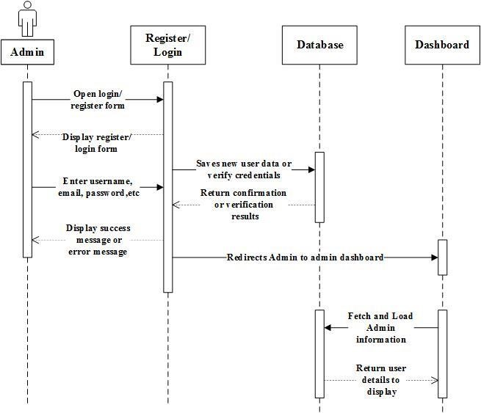

Figure 31: Sequence Diagram for Registration & Logi

2. Manage User

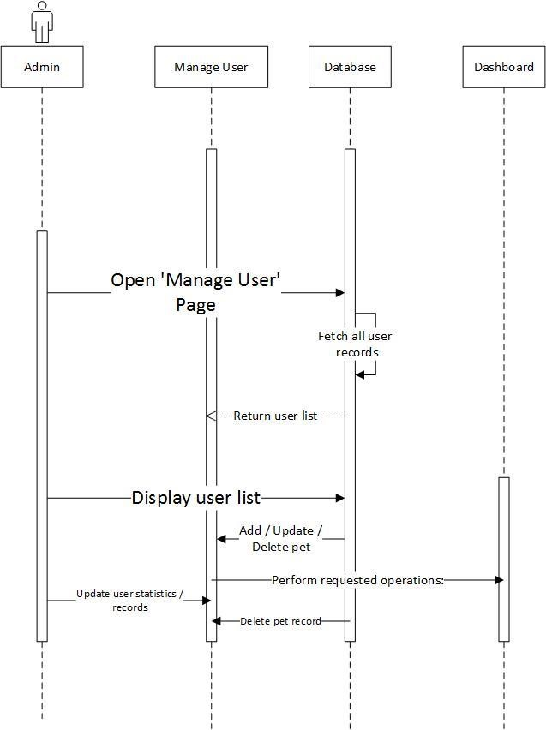
Figure 32: Sequence Diagram for Manage User 3. Manage Pets
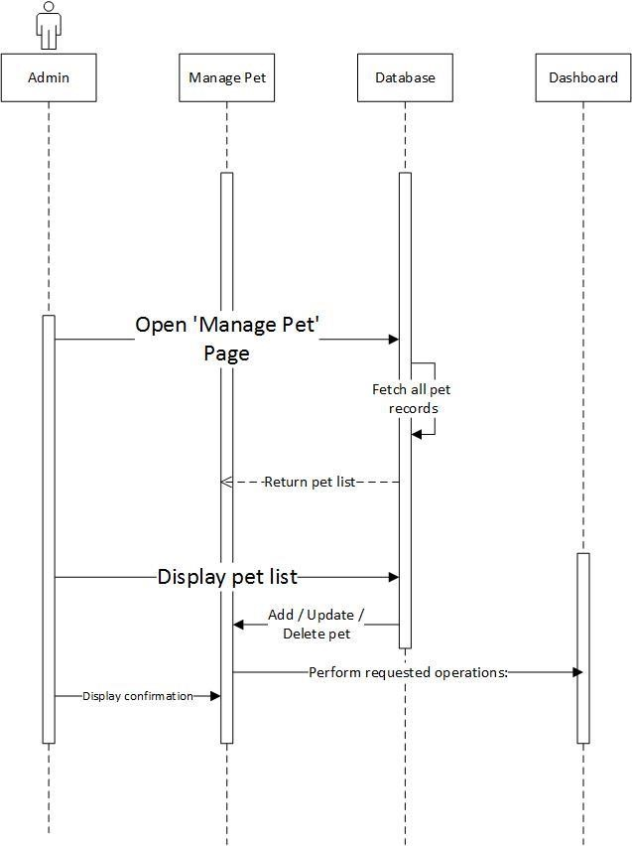
Figure 32: Sequence Diagram for Manage Pets

4. Manage Appointments
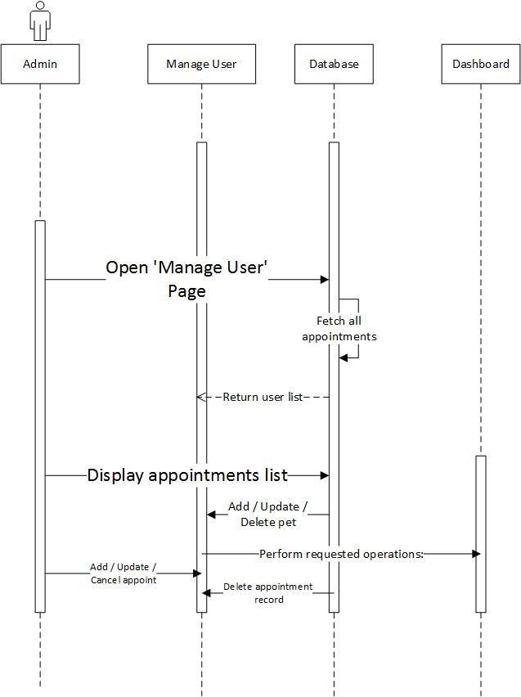
Figure 32: Sequence Diagram for Manage Appointment

5. Manage Doctors
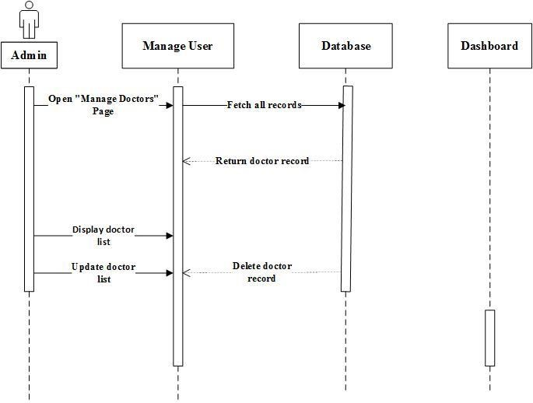
Figure 32: Sequence Diagram for Manage Doctors

6. Manage Payments
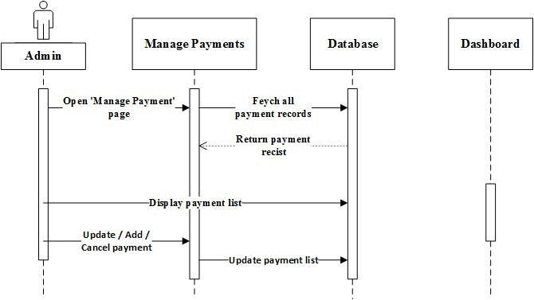
Figure 32: Sequence Diagram for Manage Payments 7. Manage Order
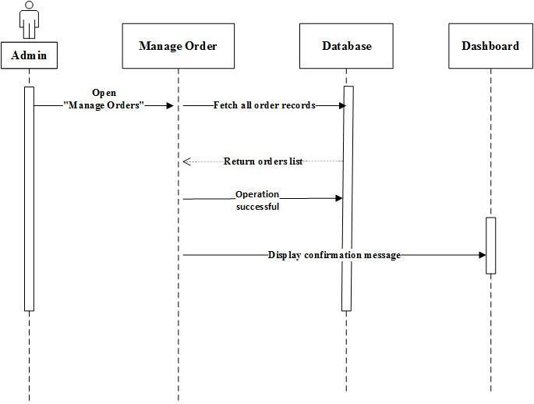
Figure 32: Sequence Diagram for Manage Order

8. Manage Vaccination
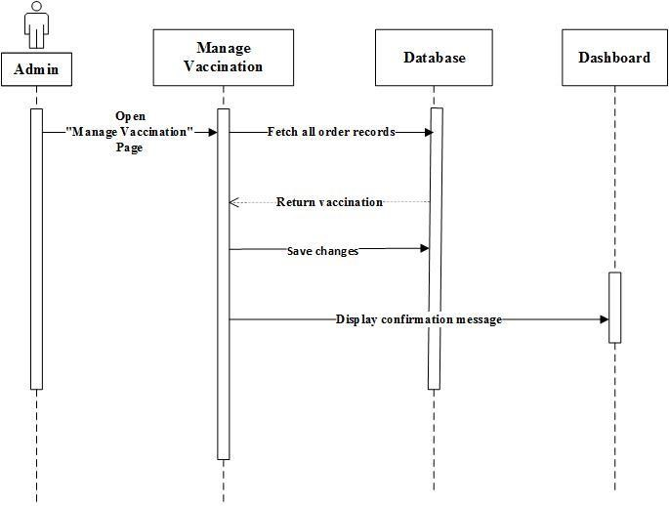
Figure 32: Sequence Diagram for Manage Vaccination

9. Manage Pet Health

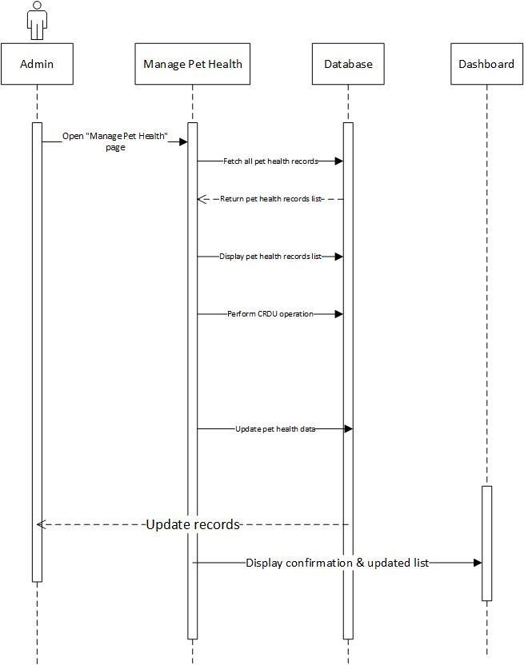
Figure 32: Sequence Diagram for Manage Pet Health

10. Manage Subscription
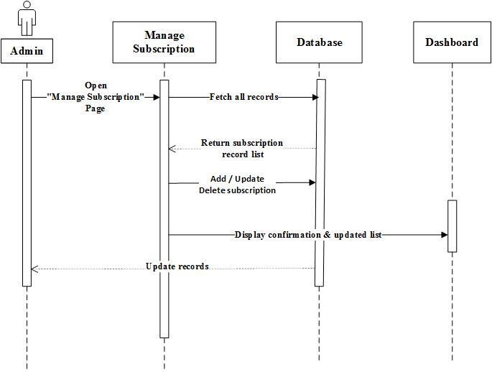
Figure 32: Sequence Diagram for Manage Subscription

11. Manage Emergency Alert

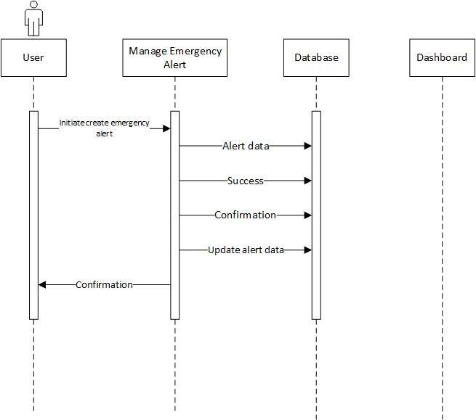
Figure 32: Sequence Diagram for Manage Emergency Alerts

1. Manage Feedback

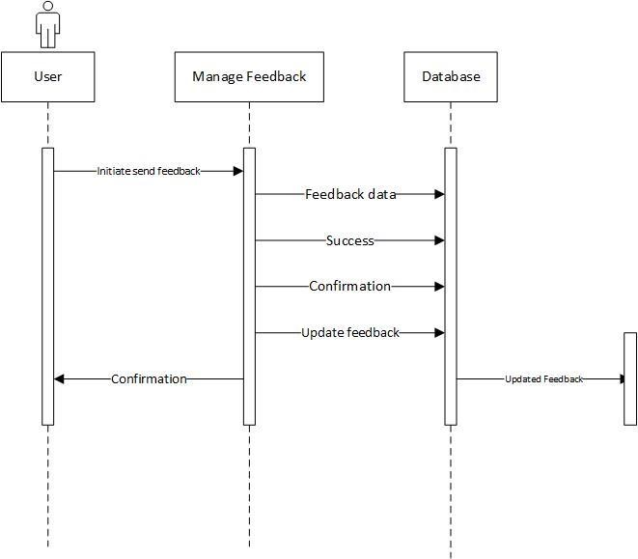

Figure 32: Sequence Diagram for Manage Feedback

1.1.2. Sequence Diagrams for Customer Panel
1. Customer Register/Login



Figure 43: Sequence Diagram for Customer Register/Login

2. Browse Service
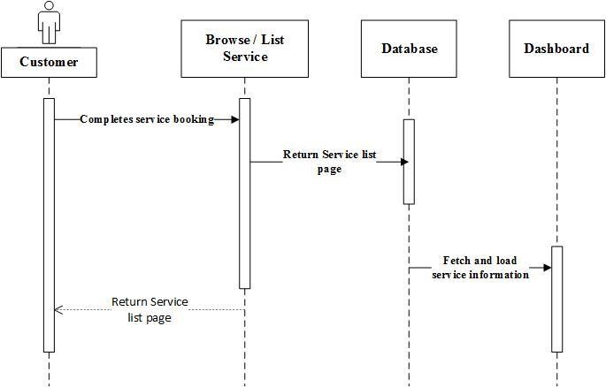
Figure 44: Sequence Diagram for Browse Service

3. Book Appointment
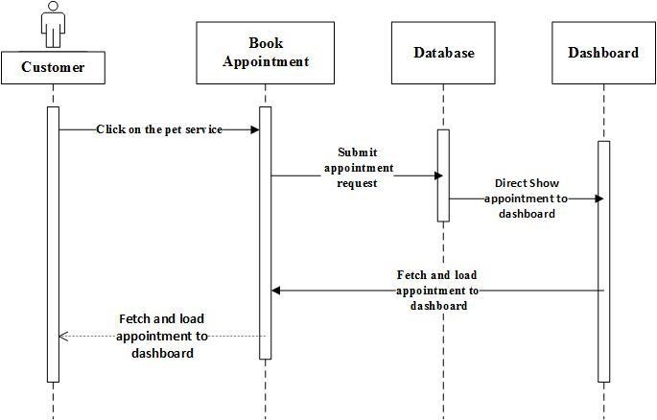
Figure 47: Sequence Diagram for Book Appointment

4-Reschedule / Cancel Appointment
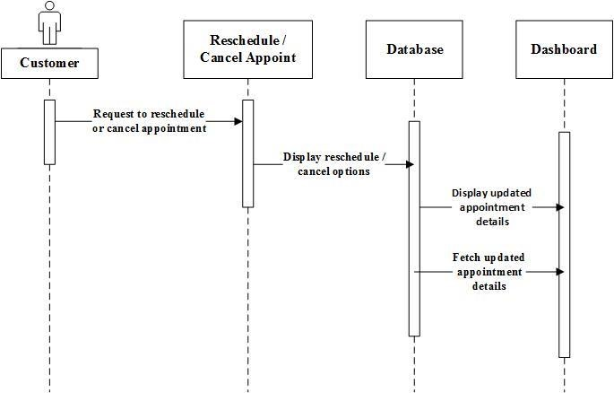
Figure 47: Sequence Diagram for Reschedule / Cancel Appointment

4. View Book history
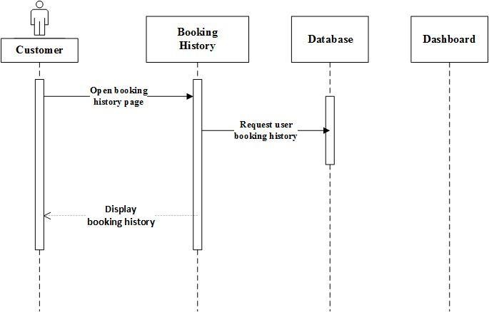
Figure 47: Sequence Diagram for Booking history

5. Payment Option
Customer
Pay
ons
ment Opti
Database
Dashboard
Select Payment option
(
online/cash) during
booking
Stores payment details
and updates payment
status
Confirms successful
payment entry
Display payment confirmation and reciept
to the customer
Figure 47: Sequence Diagram for Payment Option 6. Home Service Option
Figure 47: Sequence Diagram for Home Service Option

7. Pet Profile Management
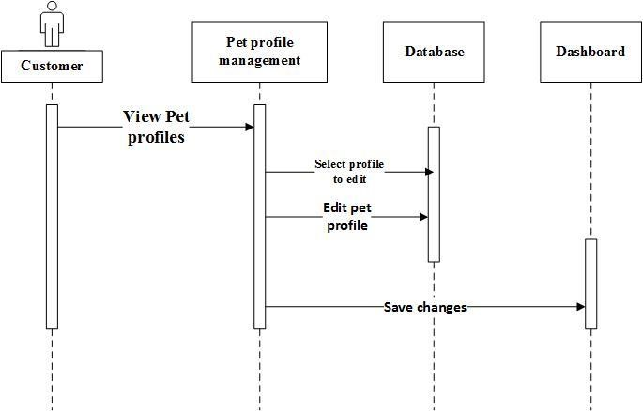
Figure 47: Sequence Diagram for Pet profile Management

8. Vaccination & Health Record
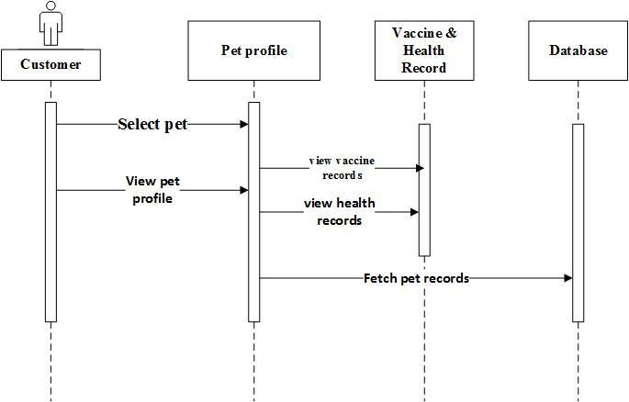
Figure 47: Sequence Diagram for Vaccination & Health Record

9. Notification & Reminders
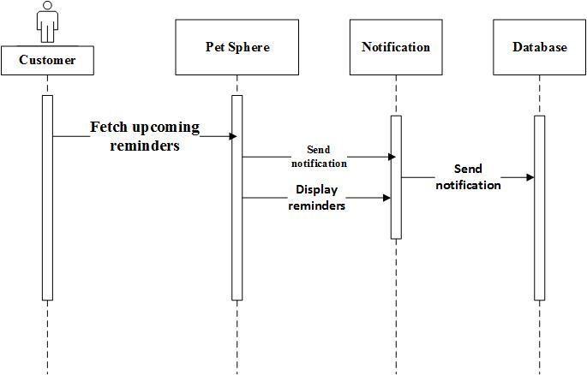
Figure 47: Sequence Diagram for Notifications & Reminders

1.1.1. Sequence Diagrams for Doctor Panel
10. Doctor Register/Login

Doctor
Register/
Login
Database
Dashboard
Open registration/
login page
Display registeration/
login form
Enter username,
email,password.etc
Save new user
data or verify
credentials
Return confirmation
or verification

details
Display success
message or
error message
Redirect customer to customer dashboard
after successful login
Fetch and load
customer information
Return user details
to display

Figure 47: Sequence Diagram for Register & Login

1. Manage Availability
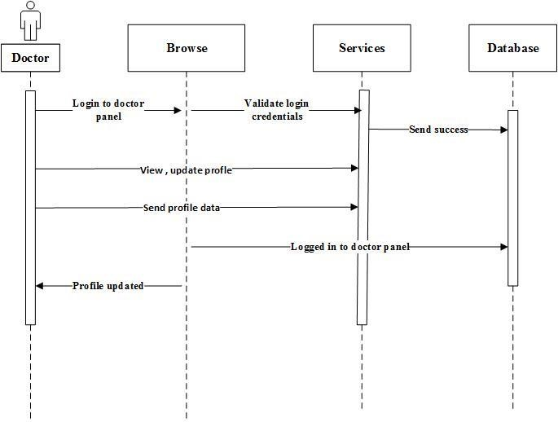
Figure 47: Sequence Diagram for Manage Availability

2. View Appointment
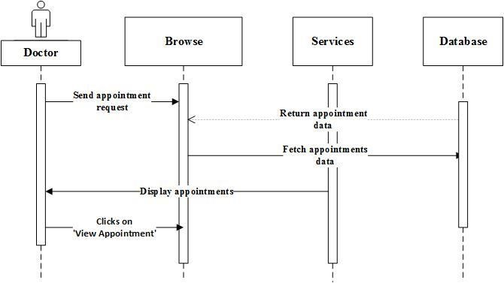
Figure 47: Sequence Diagram for View Appointment

1. Accept & Reject Appointment
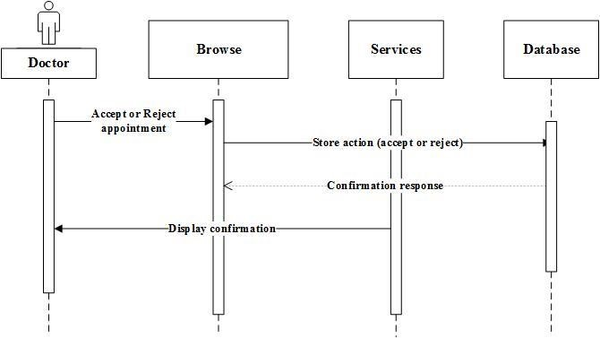
Figure 47: Sequence Diagram for Accept & Reject Appointment

2. Update Appointment Status

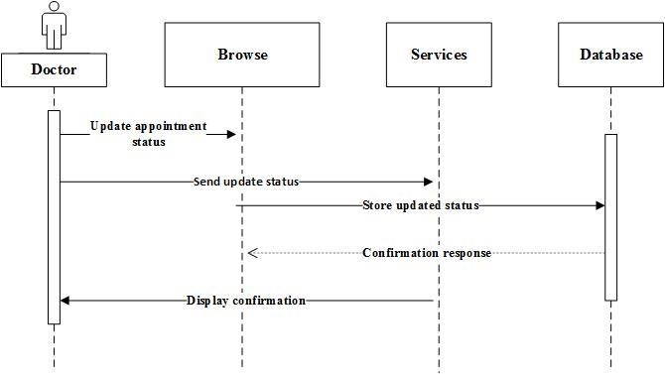
Figure 47: Sequence Diagram for Update Appointment Status

3. Add Consultation Notes
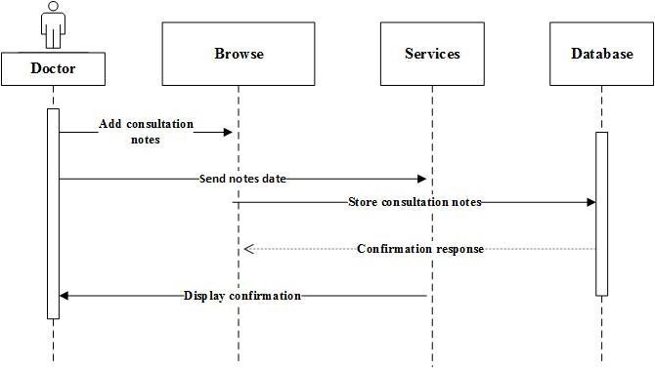
Figure 47: Sequence Diagram for Add consultation Notes 4. Update Pet health Record
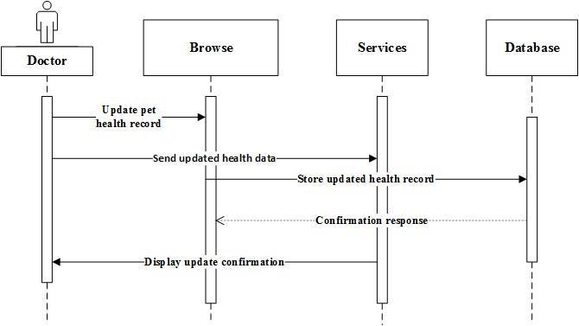
Figure 47: Sequence Diagram for Update Pet health Record

5. Update Vaccination Record
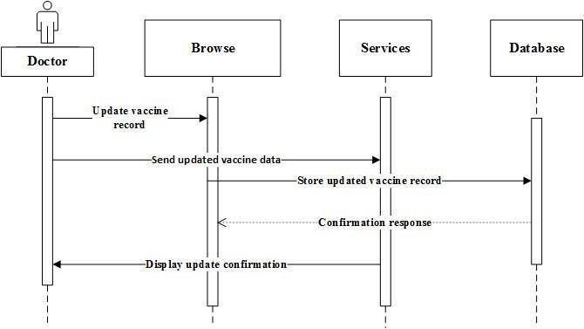
Figure 47: Sequence Diagram for Update Vaccination Record 6. View payment info
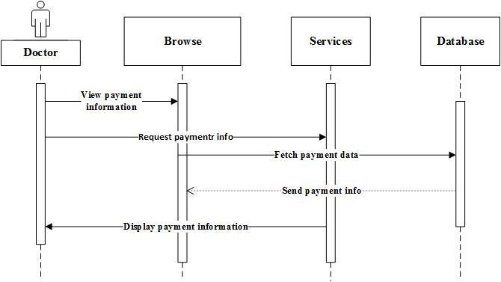
Figure 47: Sequence Diagram for Update Vaccination Record

7. Respond to Emergency Alerts

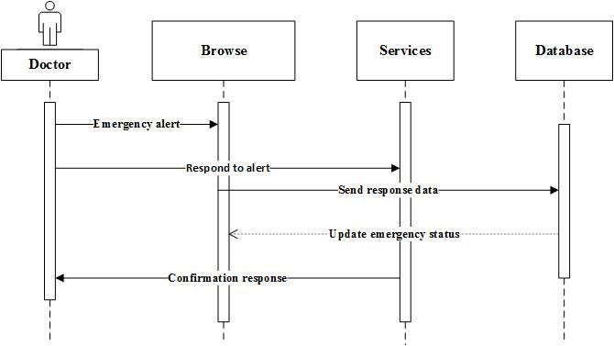
Figure 47: Sequence Diagram for Respond to Emergency Alert

8. View Customer pet history

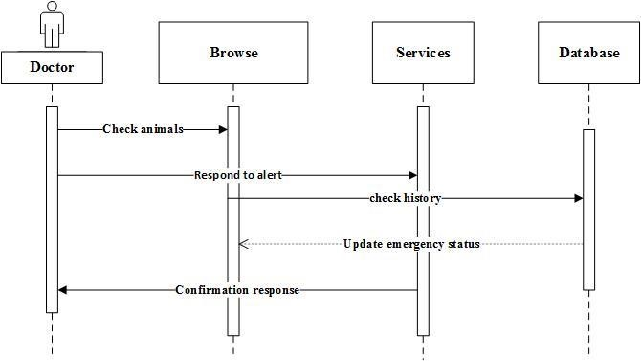
Figure 47: Sequence Diagram for View Customer pet history

1.2. State Transition Diagram
A State Transition Diagram shows how a system or object changes from one state to another based on specific events or actions. It represents the system’s behavior using states, transitions, and events. It helps visualize how different user actions or system events cause changes in the system’s workflow.
1.2.1. State Transition Diagram for Admin Panel

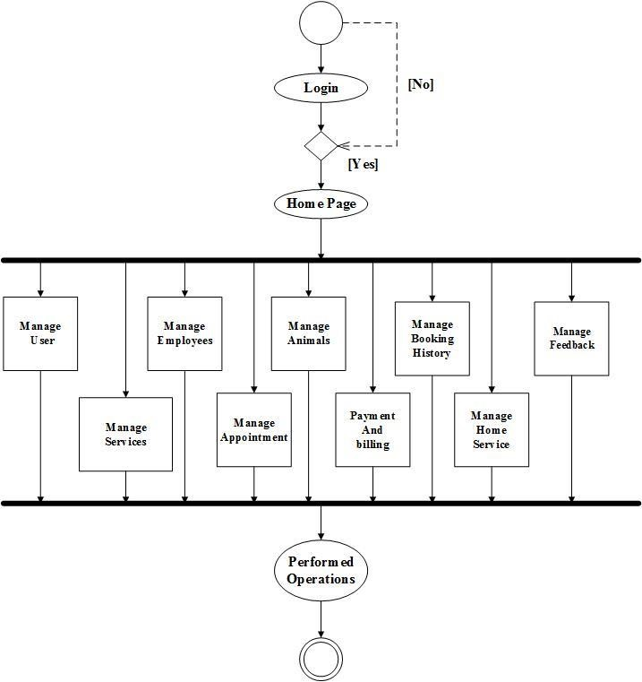
Figure 53: State diagram for Admin
1.2.2. State Transition Diagram for Customer

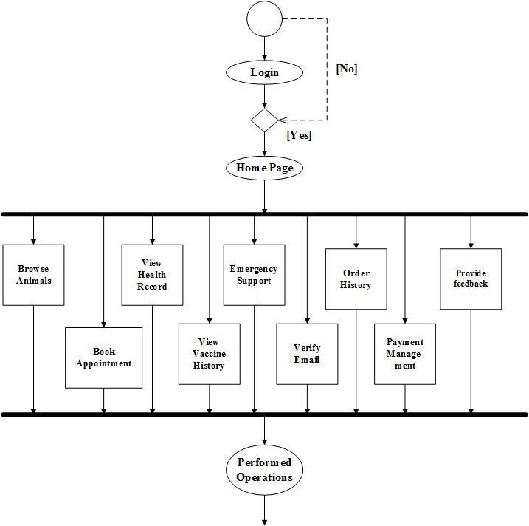

Figure 53: State diagram for Customer

1.2.3. State Transition Diagram for Doctor

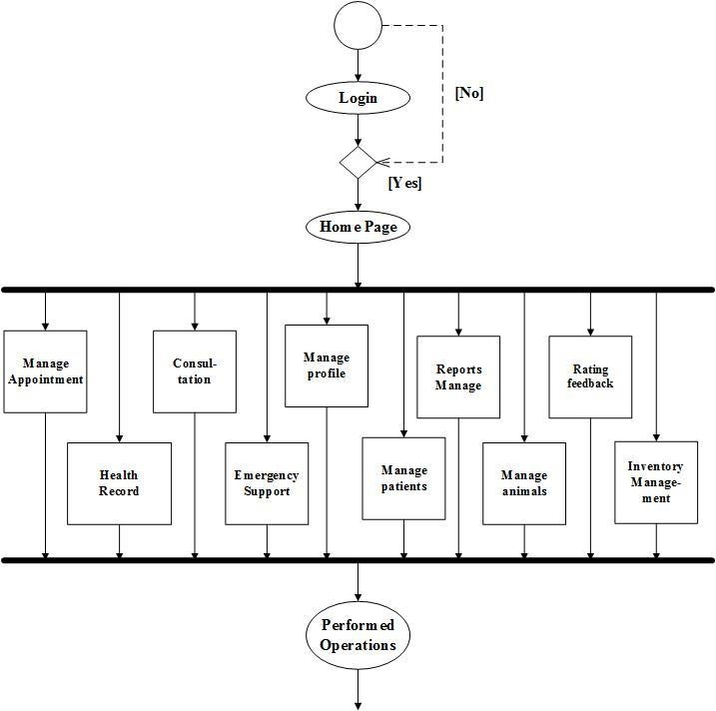
Figure 53: State diagram for Doctor

1.3. Collaboration Diagram:
A collaboration diagram, also called a communication diagram or interaction diagram, is an illustration of the relationships and interactions among software objects in the Unified Modelling Language (UML).
1.3.1. Collaboration Diagram for Admin Panel:

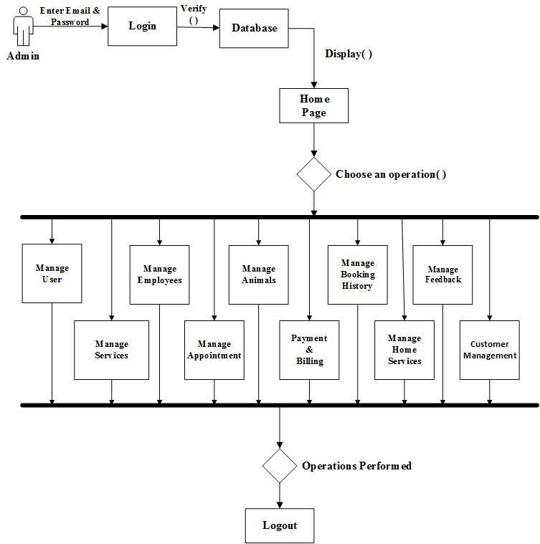

Figure 56: Collaboration Diagram for Admin Panel
1.3.2. Collaboration Diagram for Customer Panel:

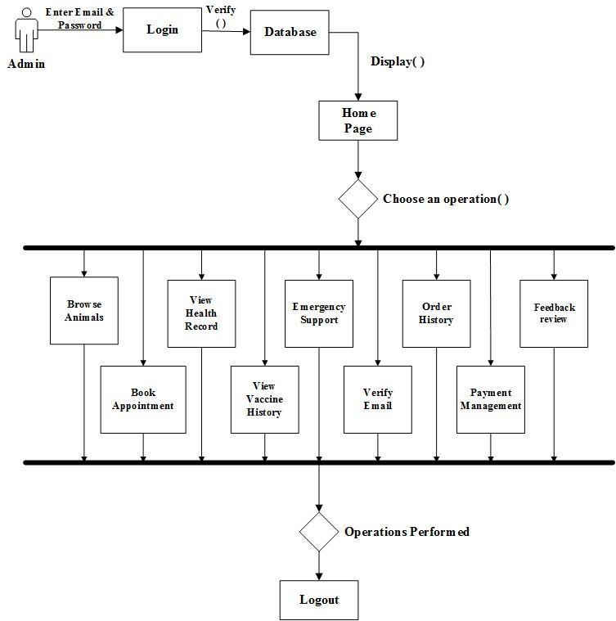
Figure 56: Collaboration Diagram for Customer Panel
1.3.3. Collaboration Diagram for Doctor Panel:

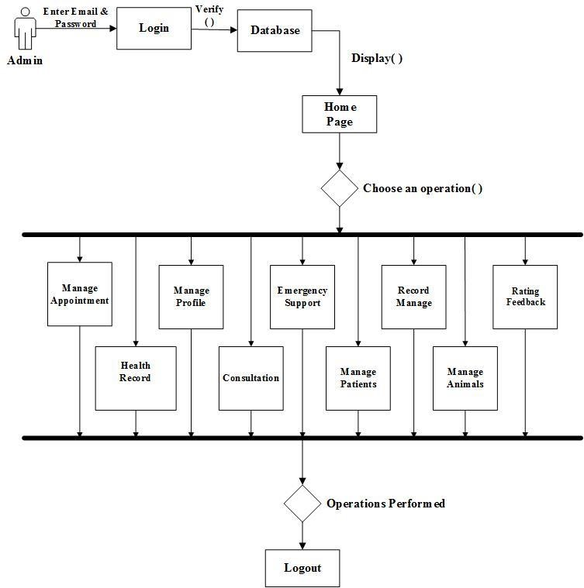
Figure 56: Collaboration Diagram for Doctor Panel

1.4. Activity Diagram
The activity diagram is a flowchart to represent the flow of control among the activity in a system.
1.4.1. Activity Diagram for Admin
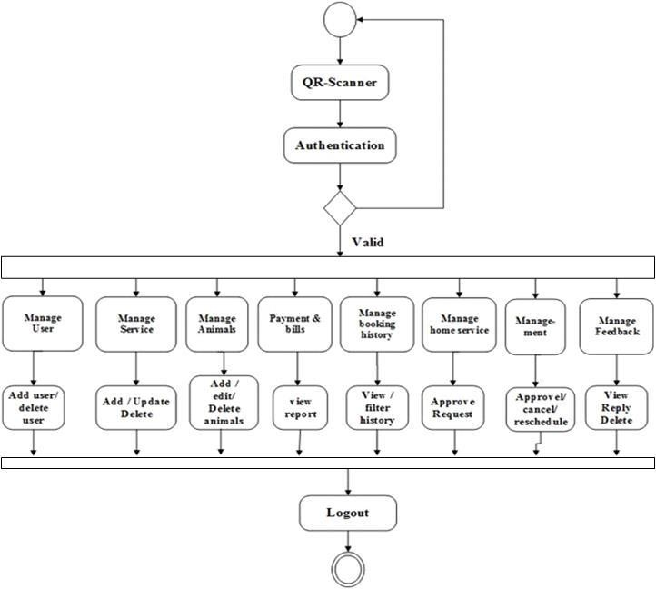
Figure 56: Activity Diagram for Admin Panel

1.4.2. Activity Diagram for Customer

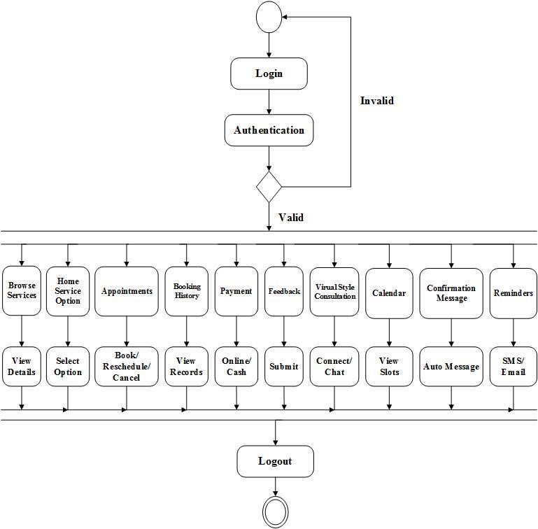
Figure 56: Activity Diagram for Customer Panel

1.4.3. Activity Diagram for Doctor
Manage
Appointment
Manage
Patient
View /
Accept/
Decline
Detail or
follow
-
up
login
Authentication
Logout
Valid
View/
Delete/
Rating
Inventory
manage
-
ment
View or
Update
medicines
Health
Records
Update
Vaccine
Consul
-
tation
Prescribe
Upload
Notes
Guide or
Escalate
Manage
Animal
Pet
manage
-
ment
Rating
Feedback
Emergency
Support

1.5. Object Diagram
An object diagram shows a moment-in-time view of a system. It displays actual objects (instances) and the links between them. It helps you understand how different parts of the system interact at runtime.

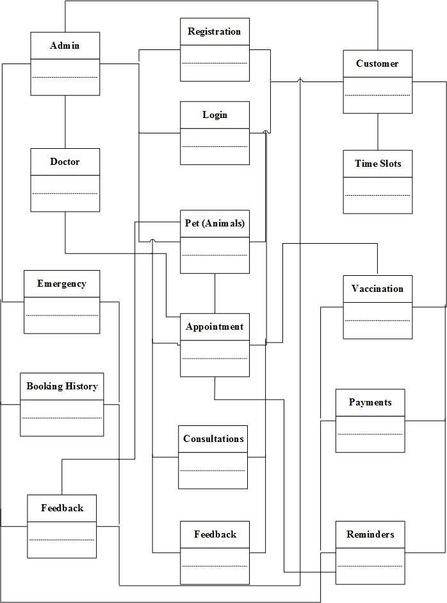

1.1. Class Diagram
A class diagram is a type of UML diagram that shows the structure of a system by depicting its classes, their attributes, methods (functions), and the relationships between them. It helps in understanding how different parts of a system interact and are organized.
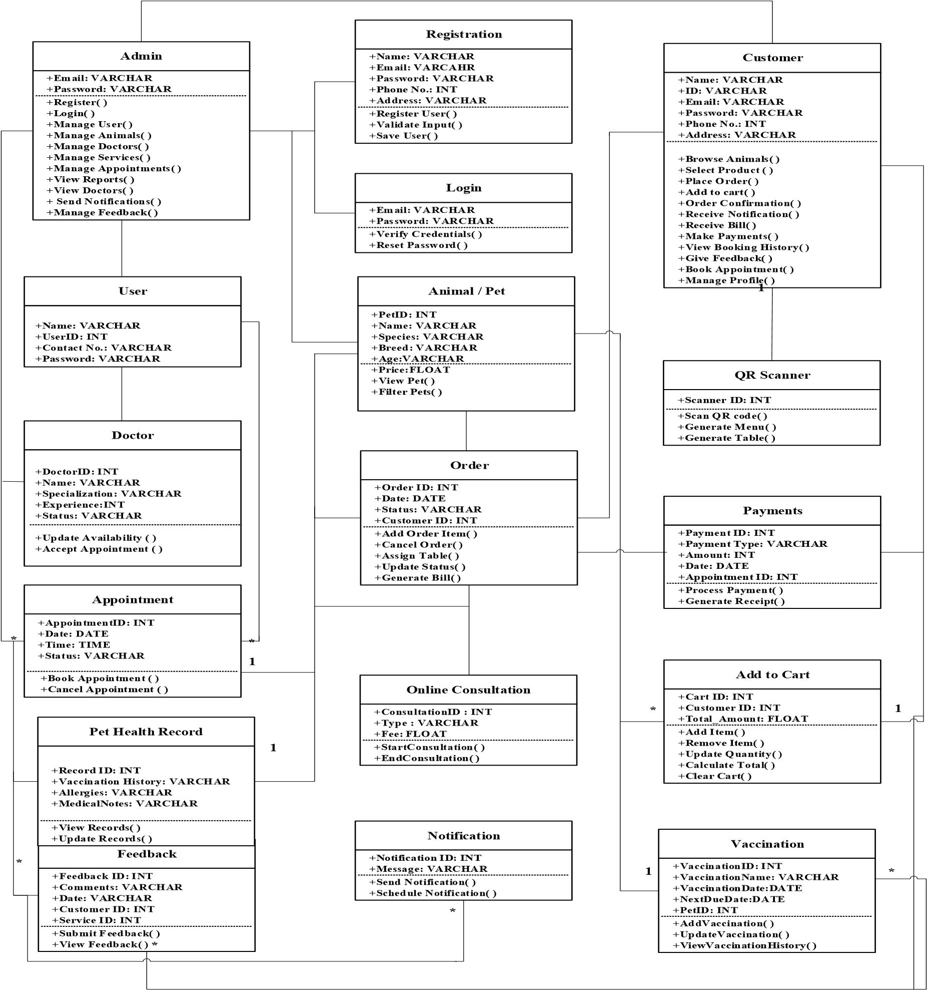

1.6. Data Flow Diagram
A Data Flow Diagram (DFD) is a visual representation that shows how data moves through a system. It depicts the processes that transform data, the stores where data is kept, and the flow of information between processes, data stores, and external entities such as users or other systems. Essentially, it illustrates how data enters a system, how it is processed, and where it goes, providing a clear picture of the system’s information flow.
1.6.1. Data Flow Diagram Level 0
A Level 0 Data Flow Diagram is a high-level overview of a system that shows the system as a single process along with its interactions with external entities. It represents the main inputs to the system, the major outputs from the system, and the external sources or destinations of data, but it does not show the detailed internal processes. Essentially, Level 0 gives a “big picture” view of the system without going into the specifics of how the processes work internally.

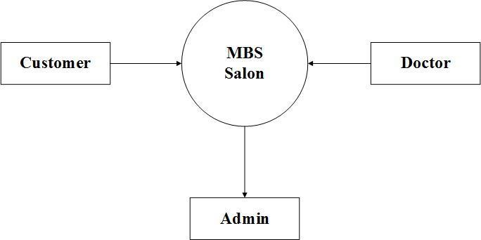

Figure 62: Data Flow Diagram Level 0

1.6.2. Data Flow Diagram Level 1
A Level 1 Data Flow Diagram breaks down the single process of Level 0 into multiple detailed subprocesses. It shows how data moves between these subprocesses, data stores, and external entities, providing a more detailed view of the system’s internal workings.
Reister/
Login
Services
Employee
Appointments
Payments
Feedback
Admin
Customer
Stores Data
Confirmation
Login
Stores Data
Stores Data
Stores Data
Stores Data
Stores Data
Login
Confirmation
View Services Request
Display Services List
Appointment
Request
Appointment
Confirmation
Payment Receipt
Makes Payment
Gives Feedback
Confirmation
View Feedback Request
Feedback Details
View Payment Requests
Payment Reports
Approve/Reschedule/Cancel
Appointments
Appointment Details
Add/Update/Delete Employee
Details

Employee Details
Add/Update/Delete Services
Services Details
To Login
To Services
To Employees
To
Appointments
To Payments
To Feedback

1.6.3. Data Flow Diagram Level 2
A Level 2 Data Flow Diagram provides an even more detailed view by breaking down the Level 1 subprocesses into smaller, specific processes.

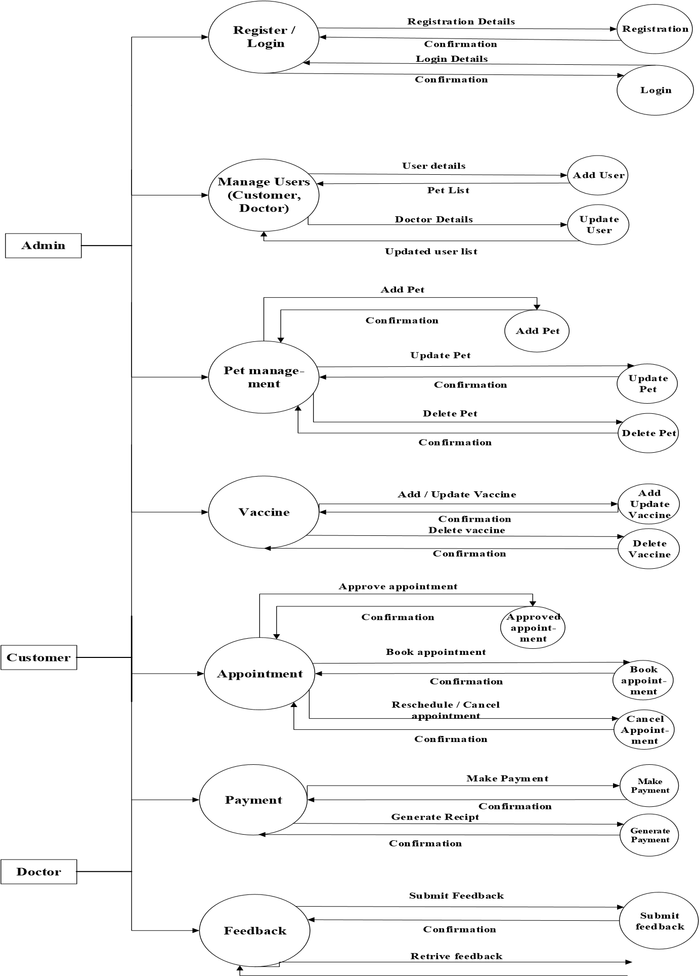

2- Project Design

4.1 Methodology
A methodology consists of structured methods, procedures, and rules used within a specific discipline. Its primary objective is to provide a systematic and organized approach to software development. A Project Management Methodology is a collection of tools, techniques, and best practices used to plan, execute, monitor, and manage a project effectively. It assists project managers in coordinating team activities, managing resources, and ensuring timely and successful project completion.
For the Pet Sphere project, the development team follows a well-defined set of processes to initiate, plan, analyze, design, develop, test, and deploy the system. Various project management methodologies such as Waterfall, Agile, and Scrum were studied. However, Agile methodology was selected for this project due to its iterative nature, flexibility, and ability to adapt to changing requirements, which is essential for a dynamic web-based system like Pet Sphere.

4.1.1 Agile Methodology
Agile is a project management approach that is best suited for projects where requirements are not fully defined at the beginning. Its core principles include continuous delivery, iterative development, adaptability, collaboration, and short development cycles.

In Agile methodology, the Pet Sphere project is divided into smaller and manageable development cycles known as sprints, typically ranging from 1 to 4 weeks. Each sprint focuses on delivering a functional and testable part of the system. A cross-functional team of developers, designers, and stakeholders works collaboratively to deliver a potentially shippable product increment at the end of each sprint. Regular meetings are conducted to review progress, identify issues, and adjust the project scope based on feedback.

Agile Values for Pet Sphere
- Customer satisfaction
- Collaboration among team members
- Continuous improvement
- Frequent communication and feedback
- Flexible response to changing user requirements
Agile emphasizes continuous planning, execution, evaluation, and improvement instead of rigidly following a single development plan.

Sprint 1: Project Planning
During this stage, the feasibility of developing the Pet Sphere system is evaluated. This includes identifying user needs such as pet browsing and purchasing, veterinary appointment booking, online consultations, pet health record management, vaccination tracking, emergency support services, and online medicine purchasing. Administrative requirements such as user management, doctor verification, appointment management, order tracking, and report generation are also identified.
Roles and responsibilities are assigned to each team member, and timelines are defined for the development of key features, including:
- User registration and login
- Pet marketplace browsing and filtering
- Veterinary doctor profiles and availability
- Appointment booking and management
- Online payment integration
Continuous interaction with stakeholders ensures that system objectives and expectations are clearly defined.

Sprint 2: Requirement Gathering
Requirement gathering is one of the most critical phases of the Agile methodology, as improper requirement collection can lead to major issues during development.
In this phase:
- Detailed discussions are conducted with potential users, veterinary professionals, and system administrators.
- Customer Panel requirements are gathered, including registration/login, pet browsing, pet purchasing, appointment booking, online consultations, pet profile management, vaccination records, emergency alerts, payment processing, notifications, and feedback.
- Veterinary Doctor Panel requirements are collected, including profile management, availability status, appointment handling, online consultation management, and prescription handling.
- Admin Panel requirements are gathered, including user management, pet listings management, doctor verification, appointment scheduling, order tracking, system analytics, and report generation.
All requirements are documented, reviewed, and approved before the development phase begins.

Sprint 3: Analysis
The analysis phase focuses on defining and organizing the system requirements to ensure clarity and feasibility.
The following steps are performed:
- Review and validate each requirement for completeness and accuracy.
- Prioritize system features based on importance and complexity.
- Estimate development time and resources required for each module.
- Design overall system architecture and data flow.
- Identify potential risks and technical challenges.
This phase ensures that Pet Sphere meets the functional and non-functional requirements of customers, veterinary doctors, and administrators.

Sprint 4: Development
The development phase involves simultaneous frontend and backend development to build a fully functional web application.

Frontend and Backend Integration
User interfaces and server-side logic are developed concurrently to ensure smooth interaction between system components.

Frontend Development
The frontend is developed using React.js and CSS, focusing on creating a clean, responsive, and userfriendly interface for:
- Customer Panel
- Veterinary Doctor Panel
- Admin Panel
Interfaces include dashboards, pet listings, appointment scheduling, online consultation screens, payment forms, health record views, emergency alert buttons, and notification panels.

Backend Development
The backend is implemented using Node.js and Express.js. It includes:
- Database schema design using MongoDB for users, pets, doctors, appointments, health records, orders, and payments.
- RESTful APIs for authentication, bookings, consultations, payments, notifications, and admin operations.
- Integration of online payment gateways such as Jazz Cash and Easy Paisa.

Testing During Development
Unit testing and integration testing are conducted continuously to identify and resolve issues early, ensuring system stability and reliability.

Sprint 5: Testing
Testing is performed to verify that all features of the Pet Sphere system function correctly and meet user expectations.

Types of Testing
- Unit Testing
- Integration Testing
- System Testing
- User Acceptance Testing (UAT)
The following functionalities are thoroughly tested:
- Pet browsing and purchasing process
- Veterinary appointment booking and availability management
- Online consultation and payment processing
- Pet health record storage and vaccination reminders
- Emergency support and notification system
- Admin management features

Identified bugs are fixed, and necessary improvements are made before deployment.
Sprint 6: Deployment In this phase:
- The Pet Sphere system is deployed to a live production environment using Vercel.
- System performance is optimized.
- Security checks are finalized.
- Remaining issues are resolved.
- End users, veterinary doctors, and administrators begin using the system.
Deployment ensures that Pet Sphere is fully operational and ready for real-world usage.

4.1.2 Reasons for Using Agile Methodology
- Reduced Risk:
Continuous testing in each sprint minimizes the risk of system failure.
- Customer Satisfaction:
Early and frequent delivery of features ensures higher user satisfaction.
- Adaptability to Change:
Agile allows requirement changes even in later stages of development.
4.-Fast Delivery:
Functional modules are delivered incrementally within short time frames.
5-Team Support:
Agile provides a structured environment that enhances teamwork and productivity.
6-Effective Communication:
Regular meetings and reviews ensure clear and transparent communication.
7-Ensures Functional Software:
Continuous testing guarantees a working system at every stage.
8-Sustainable Development:
Developers and stakeholders maintain a steady and manageable development pace.
9-Focus on User Value:
Features are prioritized based on real user needs.
10-Better Project Control:
Agile provides improved visibility, quality control, and feedback integration.

4.2 Architecture Overview
Website architecture refers to the structured hierarchy of web pages and system components within the Pet Sphere web application. A well-designed architecture enables users to easily navigate the platform while allowing efficient communication between system components. It also helps search engines understand the relationships between different pages and services.
The web application architecture defines how system components such as the frontend interface, backend services, and database layer interact with each other. It ensures reliable data exchange, system scalability, security, and performance.
The Pet Sphere system follows a 3-Tier Architecture, which consists of the following layers:
- Presentation Layer / Client Layer
- Application Layer / Business Logic Layer
- Data Layer / Database Layer
4.2.1 Architecture Overview Diagram

4.2.2 Architecture Overview by Layer

1. Presentation Layer: Client-Side Component (Frontend)
The presentation layer, also known as the client-side component, represents the user interface of the Pet Sphere web application. This layer allows customers, veterinary doctors, and administrators to interact with the system through a web browser. It displays system data, captures user actions, and sends requests to the backend server while presenting processed responses to users.
The frontend of Pet Sphere is developed using React.js and CSS, ensuring a responsive, interactive, and user-friendly experience.
Customer Panel Modules
- Customer Registration/Login: Secure user authentication using email or phone number.
- Browse Pets & Services: View pets available for sale with filters such as breed, age, color, and price.
- Veterinary Services: Browse available veterinarians and their specializations.
- Book/Reschedule/Cancel Appointments: Schedule physical or online consultations.
- Home Service Option: Request veterinary services at home.
- View Appointment & Order History: Access past and upcoming bookings.
- Online Payment Options: Pay using Jazz Cash or Easy Paisa.
- Pet Profile Management: Add pets and manage health details.
- Vaccination & Health Records: View and update pet medical history.
- Emergency SOS Support: Alert nearby vets, shelters, or ambulance services.
- Notifications & Reminders: Receive appointment and vaccination alerts.
- Feedback & Ratings: Submit reviews for doctors and services.
- Online Consultation: Chat or video consultation with veterinary doctors.
Veterinary Doctor Panel Modules
- Doctor Registration & Verification: Profile setup and verification.
- Profile Management: Manage specialization, experience, and consultation fees.
- Availability Status: Set availability as Available, Busy, or Offline.
- Appointment Management: Accept, reschedule, or cancel appointments. • Online Consultation Management: Conduct video or chat consultations.
- Prescription Management: Issue digital prescriptions.
- View Consultation History: Access patient interaction records.
- Earnings & Payment Tracking: Monitor consultation fees.
Admin Panel Modules
- User Management: Manage customers, doctors, and system users.
- Pet & Marketplace Management: Add, update, or remove pet listings.
- Doctor Verification & Status Management: Approve or reject doctor profiles.
- Appointment & Order Management: Monitor bookings and purchases.
- Medicine & Store Management: Manage prescribed medicines.
- Reports & Analytics: Generate sales, booking, and system usage reports.
- Emergency Support Management: Monitor SOS requests.
- Feedback Management: Review and manage user feedback.
- Notification Management: Send system-wide alerts and reminders.

2. Application Layer: Server-Side Component (Backend)
The application layer contains the core business logic of the Pet Sphere system. It processes requests received from the frontend, applies business rules, and returns appropriate responses.
This layer is developed using Node.js and Express.js and provides RESTful APIs to support frontend functionality.
Key responsibilities include:
- User authentication and authorization
- Appointment scheduling and availability checking
- Veterinary consultation management
- Payment processing
- Emergency alert handling
- Notification and reminder services
- Feedback and rating management
- Admin control and reporting
The backend ensures that:
- Appointments are not double-booked
- Doctors are available at selected times
- Secure and accurate payments are processed
- Data consistency and integrity are maintained

3. Data Layer: Database Component
The data layer is responsible for permanent and secure data storage. MongoDB is used as the database for Pet Sphere due to its scalability and flexibility.
The database stores:
- Customer profiles
- Veterinary doctor profiles
- Pet listings and pet profiles
- Appointments and consultations
- Medical records and vaccination history
- Payments and transaction records
- Emergency support logs
- Feedback and ratings • Admin reports and analytics data
The data layer ensures:
- Data integrity and consistency
- Low redundancy
- Fast data retrieval
- Secure access control
- Reliable backup and recovery

4. Backend Technology: Node.js & Express.js
Node.js is used as the backend runtime environment, providing high performance and scalability for handling multiple user requests. Express.js is used as the server framework to manage routes, APIs, and middleware efficiently.
Node.js manages:
- API request handling
- Business logic execution
- Authentication and authorization
- Appointment and consultation workflows
- Payment gateway integration
- Notification services
This technology stack ensures high efficiency, real-time processing, and smooth system performance.

5. Deployment & Development Environment
The Pet Sphere system is developed and tested locally using modern development tools. After testing, the application is deployed on Vercel, which provides fast and reliable hosting.
Deployment features include:
- Continuous deployment
- Secure HTTPS access
- Scalable infrastructure
- High availability
This ensures that Pet Sphere is accessible, secure, and ready for real-world usage.

4.3 Database Design
Database design is the process of organizing data and defining how it will be stored, accessed, and managed within a system. It involves a structured set of steps to create an efficient, secure, and reliable database that fulfills system requirements. For the Pet Sphere system, an effective database design ensures that user information, pet details, veterinary records, appointments, transactions, and emergency data are handled efficiently and securely.
A well-designed database plays a critical role in ensuring smooth system operations, data accuracy, and system scalability.
Some important points considered for designing the Pet Sphere database include:
- Data consistency and integrity to ensure accurate and reliable information.
- Low data redundancy to avoid duplicate storage of the same information. • Efficient searching and retrieval through indexing and optimized queries.
- Security measures using access control and validation rules to protect sensitive data.
- Atomic data storage, where data is stored in its smallest meaningful units (e.g., separating pet details, owner details, and medical records).
Depending on the functional requirements of the Pet Sphere system, these principles may be extended or refined; however, they form the foundation of a reliable and efficient database design.

4.3.1 Data Model
The data model defines how data is logically and physically structured within the Pet Sphere system. It serves as a blueprint for organizing data elements, defining relationships among them, and ensuring that data can be efficiently stored, accessed, and managed.
The data model helps the system support core functionalities such as pet marketplace operations, veterinary appointment scheduling, health record management, payment processing, and administrative reporting.

4.3.2 The Data Model Used in Pet Sphere
The Pet Sphere system uses a document-based (NoSQL) data model implemented through MongoDB. Unlike traditional relational databases, MongoDB stores data in flexible, JSON-like documents, which makes it suitable for handling complex and evolving data structures.
In this model:
- Each document represents a record (e.g., user, pet, appointment).
- Each field represents an attribute of that record.
- Related data can be embedded or referenced, allowing efficient data retrieval.
This data model is ideal for Pet Sphere as it efficiently manages diverse and interconnected data such as:
- Customer and veterinary doctor profiles
- Pet listings and pet profiles
- Appointments and online consultations
- Medical and vaccination records
- Orders, payments, and subscriptions
- Emergency support logs and notifications
The NoSQL data model provides scalability, flexibility, and high performance, making it suitable for a modern web-based system like Pet Sphere.

4.3.3 Entity Relationship Diagram (ERD)
An Entity Relationship Diagram (ERD) is used during the system analysis phase to visually represent the main entities involved in the Pet Sphere system and the relationships among them.
- Entities represent real-world objects such as Customer, Veterinary Doctor, Pet, Appointment, Health Record, Payment, Order, and Admin.
- Attributes define the properties of each entity, such as customer name, pet breed, doctor specialization, appointment date, and payment status.
- Relationships describe how entities interact, for example:
- One customer can own multiple pets.
- One veterinary doctor can handle many appointments.
- Each appointment is linked to one customer and one pet.
- Cardinality defines the number of instances involved in a relationship (one-to-one, oneto-many, or many-to-many).
- Modality specifies whether participation in a relationship is mandatory or optional.
The ERD provides a clear conceptual view of the database structure and serves as a guide for implementing the actual database schema in MongoDB for the Pet Sphere system.

Feedback | Reminders | Notification | Emergency | Health  Record | Home Service | Payment | Appointment | Services | Doctors | Pets | Login | Registration | Customer | Admin | Module / Entity
View | Send | Send | Monitor | Monitor | Manage | Monitor | Manage | Generate Receipt | Manage | Manage | Verify | Verify | Manage |  | Admin
Give | Receive | Receive | Use | View | Request | Pay |  | Pay | Book/Cancel | View /  Buy | Login | Register |  |  | Customer
 |  |  |  |  |  |  |  |  |  |  |  |  | Register |  | Registration
 |  |  |  |  |  |  |  |  |  |  |  |  | Login |  | Login
 |  |  |  | Linked |  |  |  |  | Is For |  |  |  | View | Manage | Pets
 |  |  | Respond | Update | Provide | Receive | Attends | Is Linked |  |  |  |  | View | Verify | Doctors
 |  |  |  |  | Available |  |  |  | Has |  |  |  | Browse | Manage | Services
 | Remind | Notify |  | Update | Linked | Linked |  |  | Assigned To |  |  |  | Book | Manage | Appointment
 |  | Notify |  |  |  |  | Has |  | Has |  |  |  | Pay | Monitor | Payment
 | Remind | Notify |  |  |  | Pay |  |  |  |  |  |  | Request | Manage | Home Service
 | Remind | Notify |  |  |  |  |  |  |  | Linked |  |  | View | Monitor | Health Record
 |  | Alert |  |  |  |  |  |  | Has |  |  |  | Trigger | Monitor | Emergency
 |  |  | Alert | Notify | Notify | Notify |  |  |  |  |  |  | View | Send | Notification
 |  |  |  | Reminder | Remind |  |  |  |  |  |  |  | View | Send | Reminder
 |  |  |  |  | Has |  |  | Linked |  |  |  |  | Give | Manage | Feedback

